**PRACTICAL FILE**

**Course Title: Visual Computing and Animation**

**Course Code: CSE316**

**Credit Units:04**



**AMITY SCHOOL OF ENGINEERING AND TECHNOLOGY**

**Department of Computer Size and Engineering**

**Uttar Pradesh, Noida.**

**Submitted to: Submitted by:**

**Leena Singh mam R. Rakesh Reddy**

**A023119819027**

**5CSE13X**

**Table of Contents:**

|  |  |  |  |
| --- | --- | --- | --- |
| **sno** | **Exp name** | **date** | **signature** |
| **1** | **Create moving objects using Open GL 3D** | **20 July 2021** |  |
| **2** | **Create moving objects using Open GL 2D** | **27 July 2021** |  |
| **3** | **Perform 2D translation with python and OpenGL.** | **3 Aug 2021** |  |
| **4** | **Perform 2D rotation with python and OpenGL.** | **10 Aug 2021** |  |
| **5** | **Perform 2D transformations (translation, rotation, scaling) with python and OpenGL.** | **17 Aug 2021** |  |
| **6** | **Perform 3D transformations (translation, rotation, scaling) with python and OpenGL.** | **24 Aug 2021** |  |
| **7** | **Implementing line drawing algorithms** | **31 Aug 2021** |  |
| **8** | **To divide screen into four regions, draw circle, rectangle, ellipse, and half ellipse in each region with appropriate message.** | **5 oct 2021** |  |
| **9** | **To create basic animation** | **16 oct 2021** |  |
| **10** | **To create a GIF in adobe Photoshop** | **23 nov 2021** |  |

**Experiment – 1 Date:** 20/7/21

**Aim:** create a moving object using Open GL 3D

**Tool and technologies used:** visual studio code (python)

Download python using your browser

<https://www.python.org/downloads/>

**Installing Open GL and pygame: (in command prompt)**

pip install PyOpenGL PyOpenGL_accelerate

pip install pygame

**Theory:**

Open GL: OpenGL is a graphics library which is supported by multiple platforms including Windows, Linux, and MacOS, and is available for use in multiple other languages as well.

Pygame: Pygame is a set of Python modules which is used to create video games. It consists of computer graphics and sound libraries designed to be used with the Python programming language.

In this experiment we are going to generate wired rotating cube, wired cube, and solid cube.

**Code:**

**Rotating wired cube:**

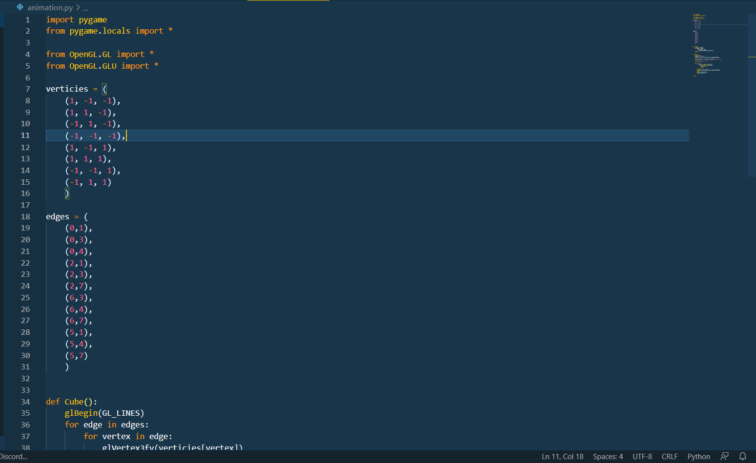

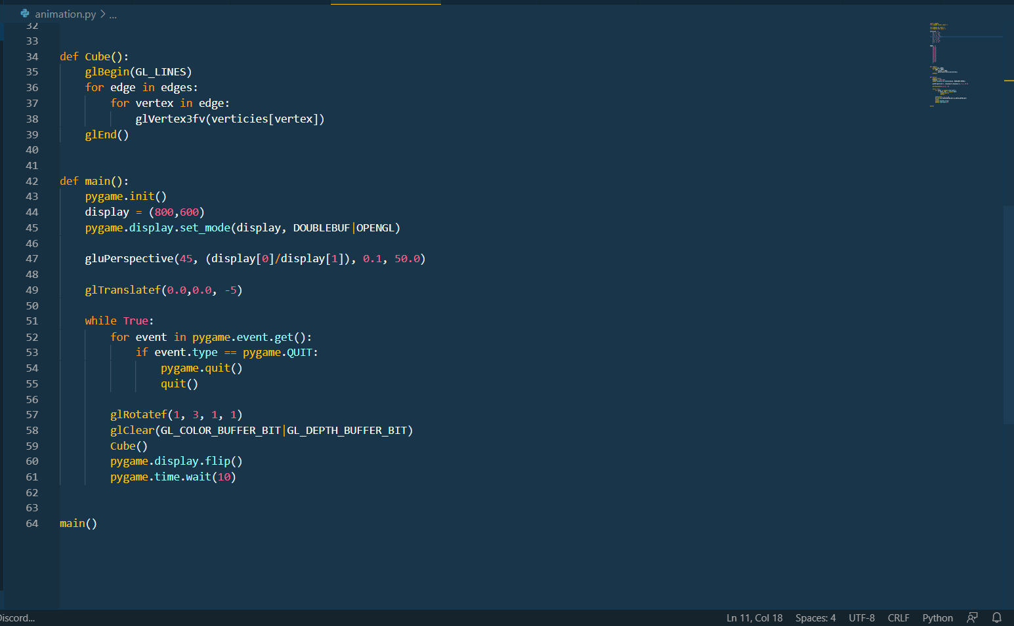

**Wired cube:**

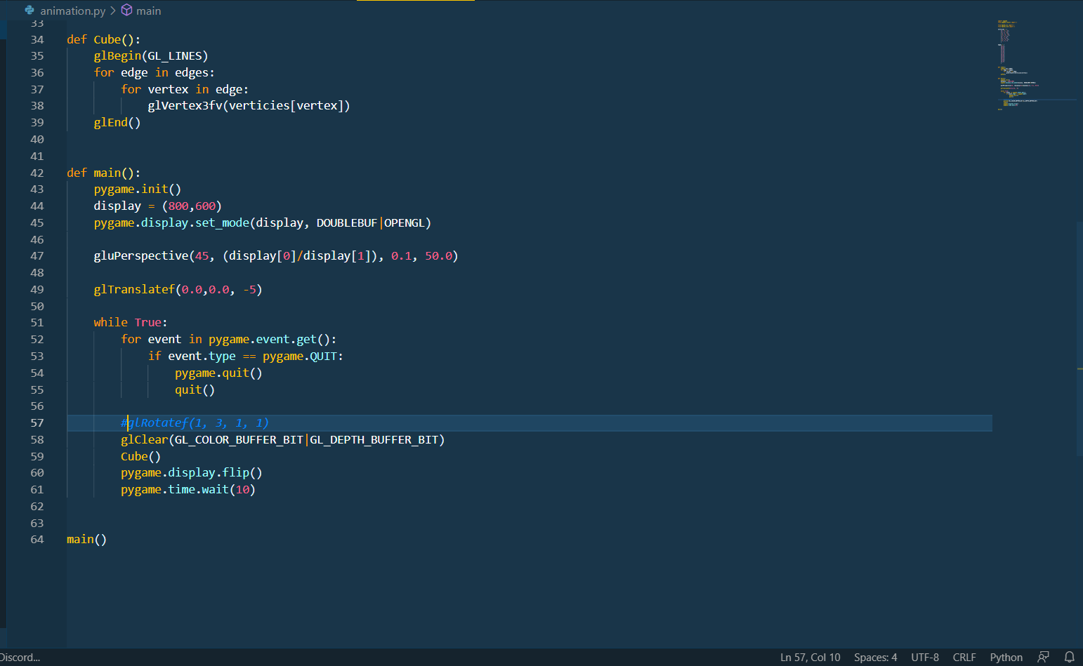

**Solid cube:**

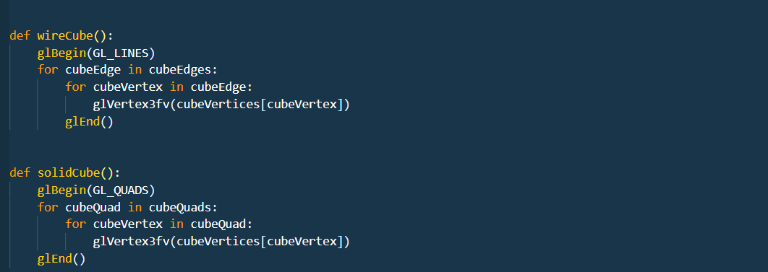

**Output:**

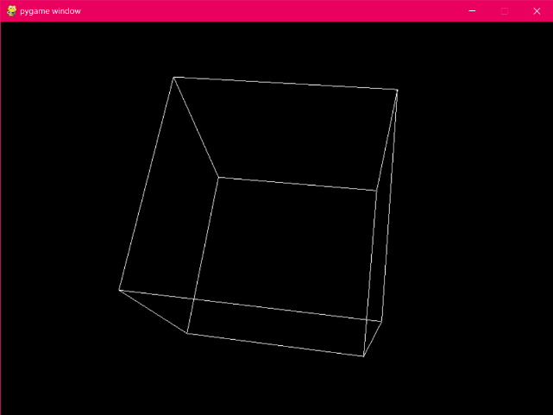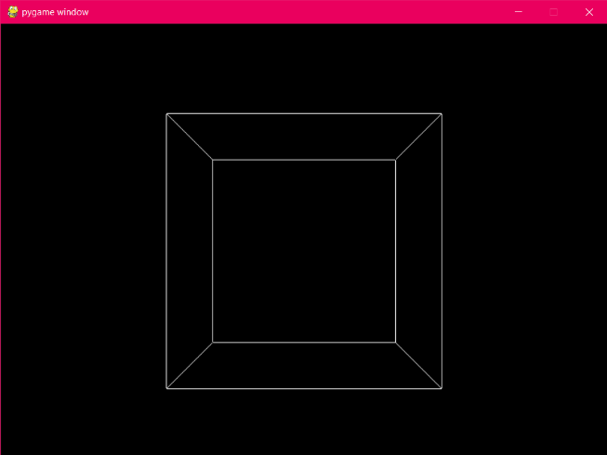

Wired rotating cube wired cube

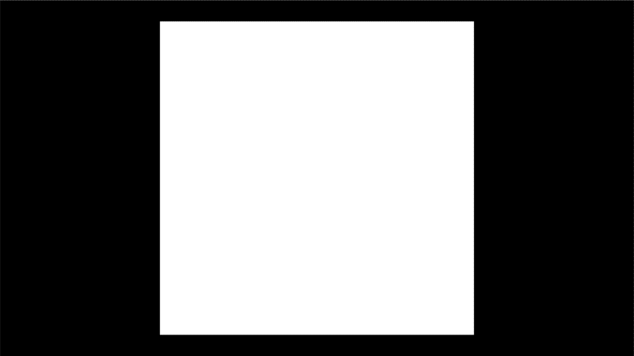

Solid cube

**Experiment – 2 Date:** 27/8/21

**Aim:** create a moving object using Open GL 2D

**Tool and technologies used:** visual studio code (python)

**Theory:**

Open GL: OpenGL is a graphics library which is supported by multiple platforms including Windows, Linux, and MacOS, and is available for use in multiple other languages as well.

Pygame: Pygame is a set of Python modules which is used to create video games. It consists of computer graphics and sound libraries designed to be used with the Python programming language.

In this experiment we are going to generate wired rotating cube, wired cube, and solid cube.

For making a rectangle:

We can use the inbuilt function glRectf to make a rectangle.

**Code:**

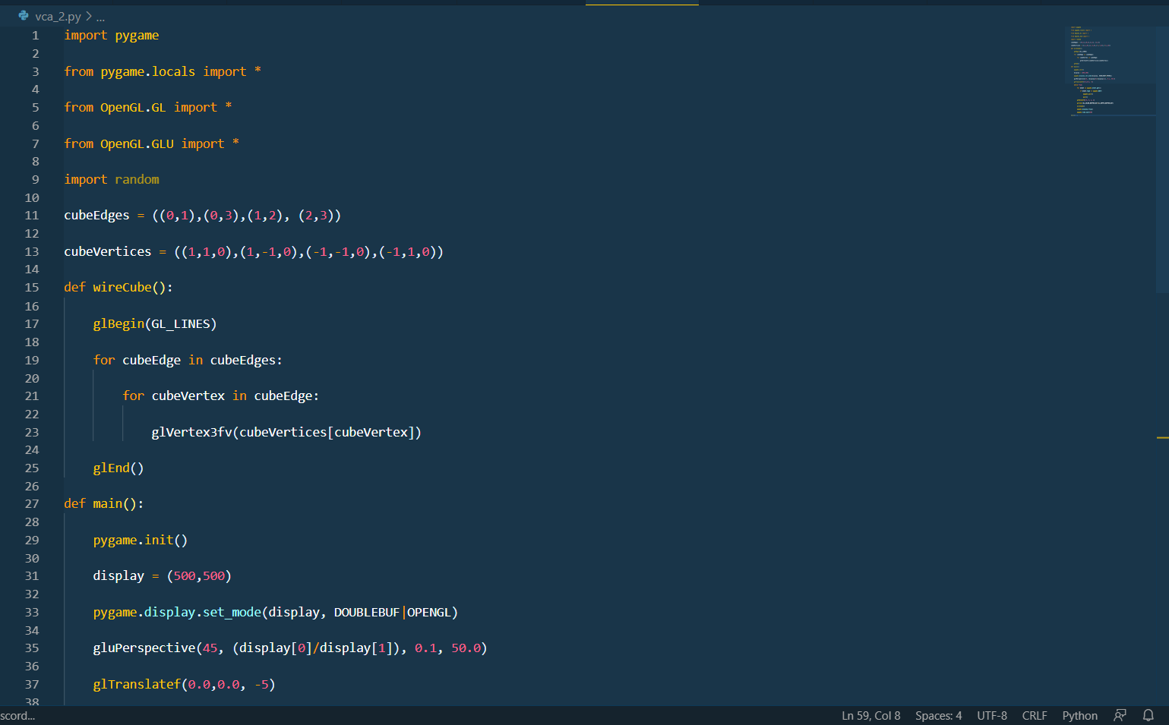

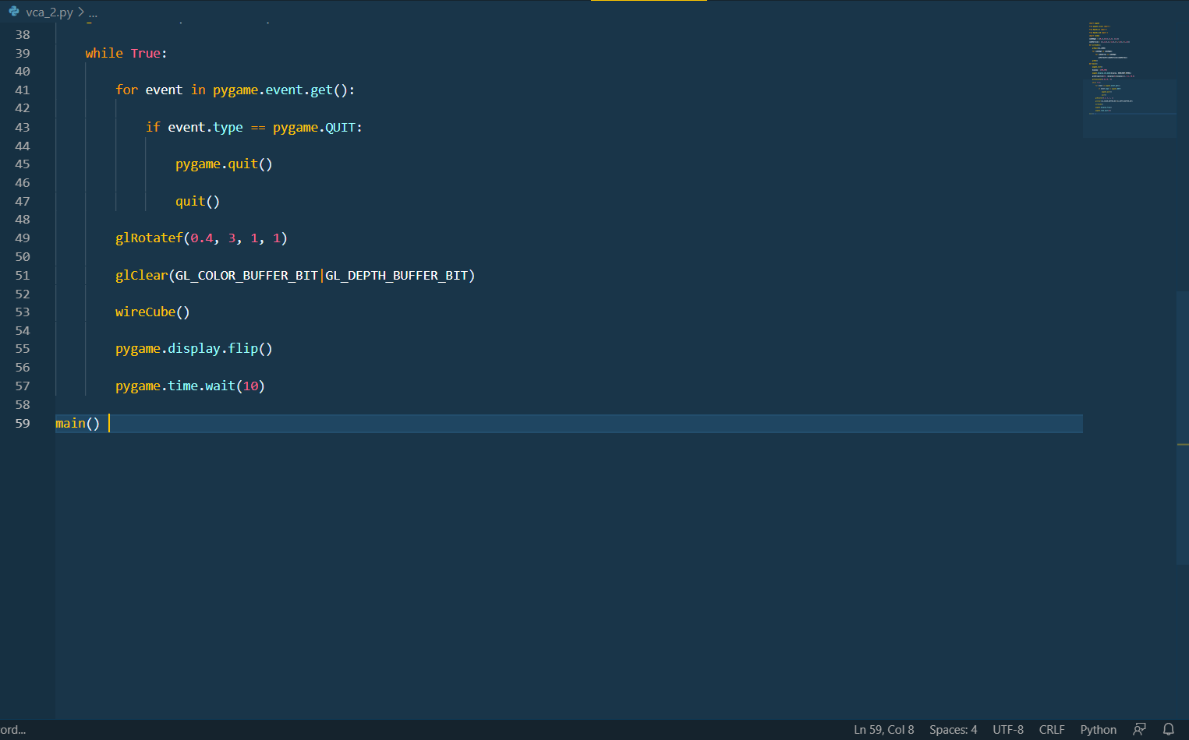

**Output:**

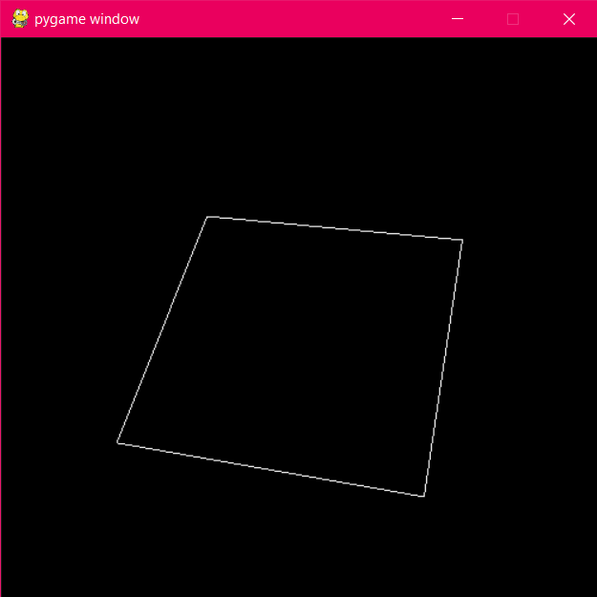

**Experiment – 3                                                     Date:**03/8/21

**Aim:** writing a program on translation of a square.

**Tool and technologies used:**visual studio code (python)

**Theory:**

**Open GL:** OpenGL is a graphics library which is supported by multiple platforms including Windows, Linux, and MacOS, and is available for use in multiple other languages as well.

Pygame: Pygame is a set of Python modules which is used to create video games. It consists of computer graphics and sound libraries designed to be used with the Python programming language.

In this experiment we take a cube and translate it to other posotion.

Code:

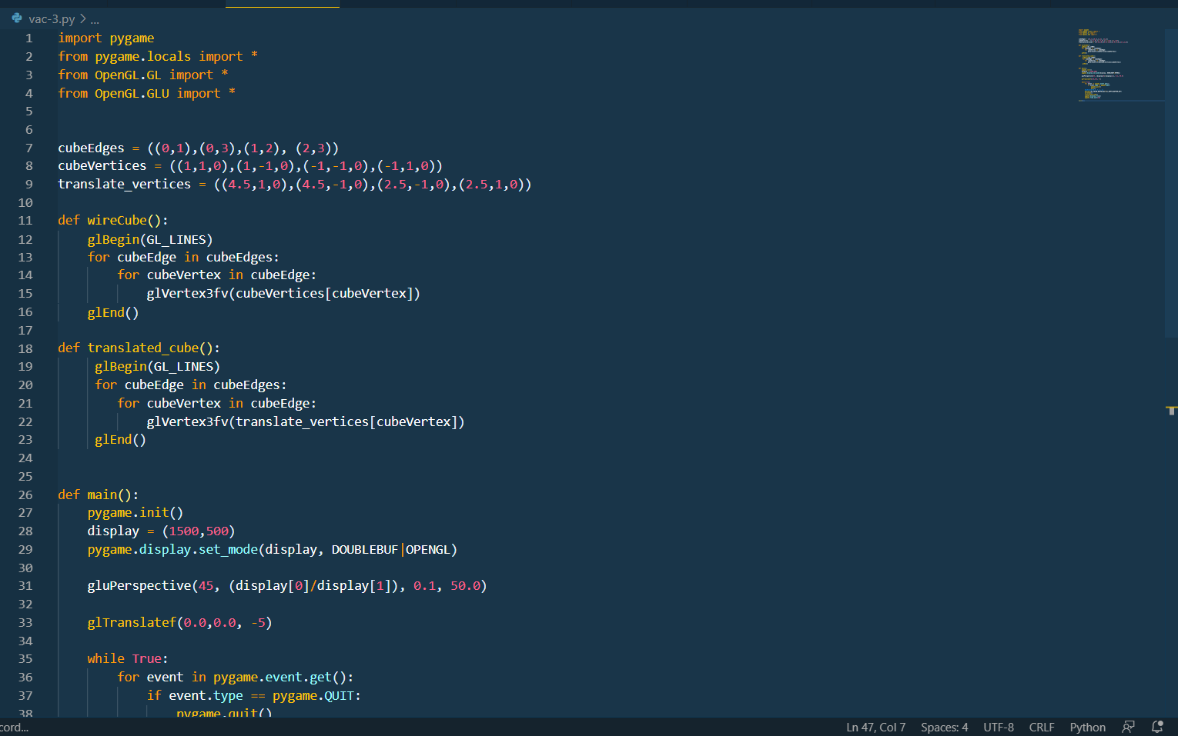

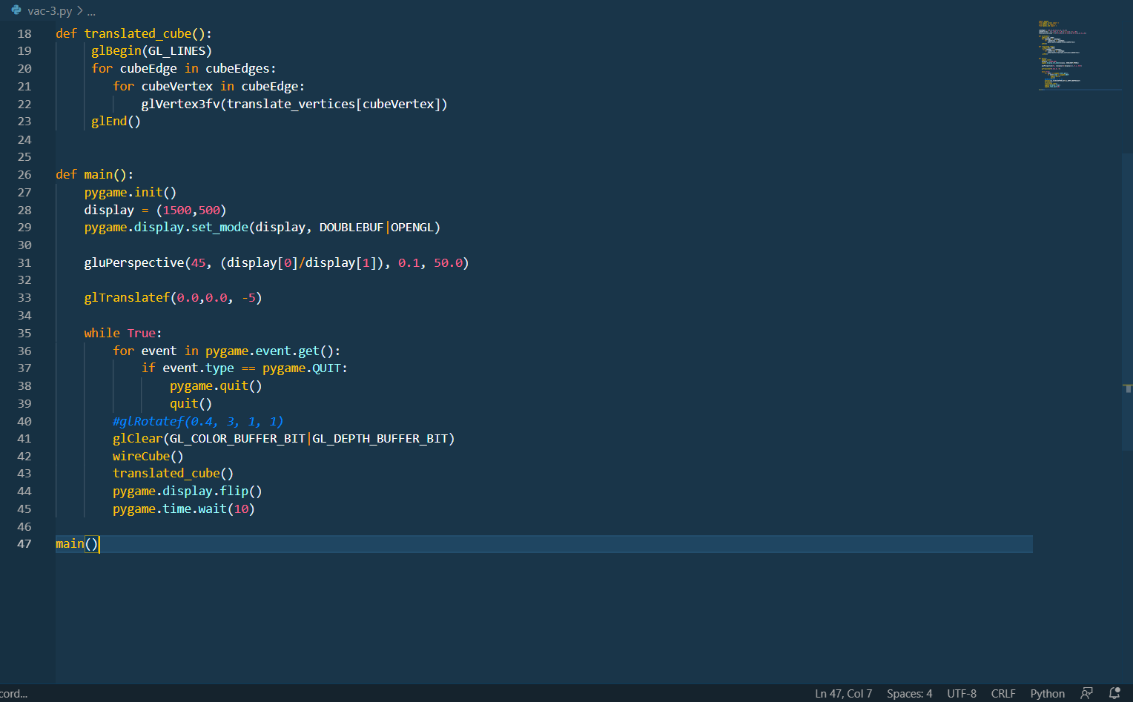

Output:

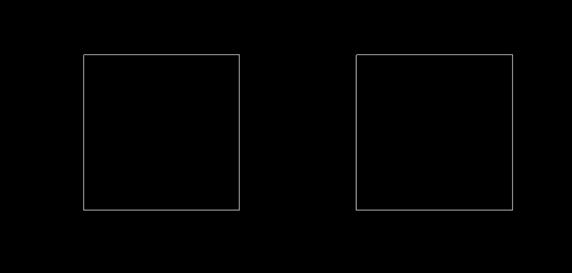

**Experiment – 4 Date: 10 Aug 2021**

**Aim:** To perform 2d rotation using python OpenGL.

**Programing Language:** python

**Theory:**

A rotation is a transformation in which the object is rotated about a fixed point or a line. The direction of rotation can be clockwise or anticlockwise. The fixed point in which the rotation takes place is called the centre of rotation. The amount of rotation made is called the angle of rotation. For any rotation, we need to specify the centre, the angle, and the direction of rotation.

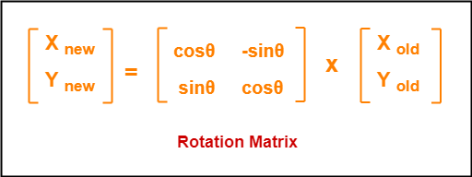

Code:

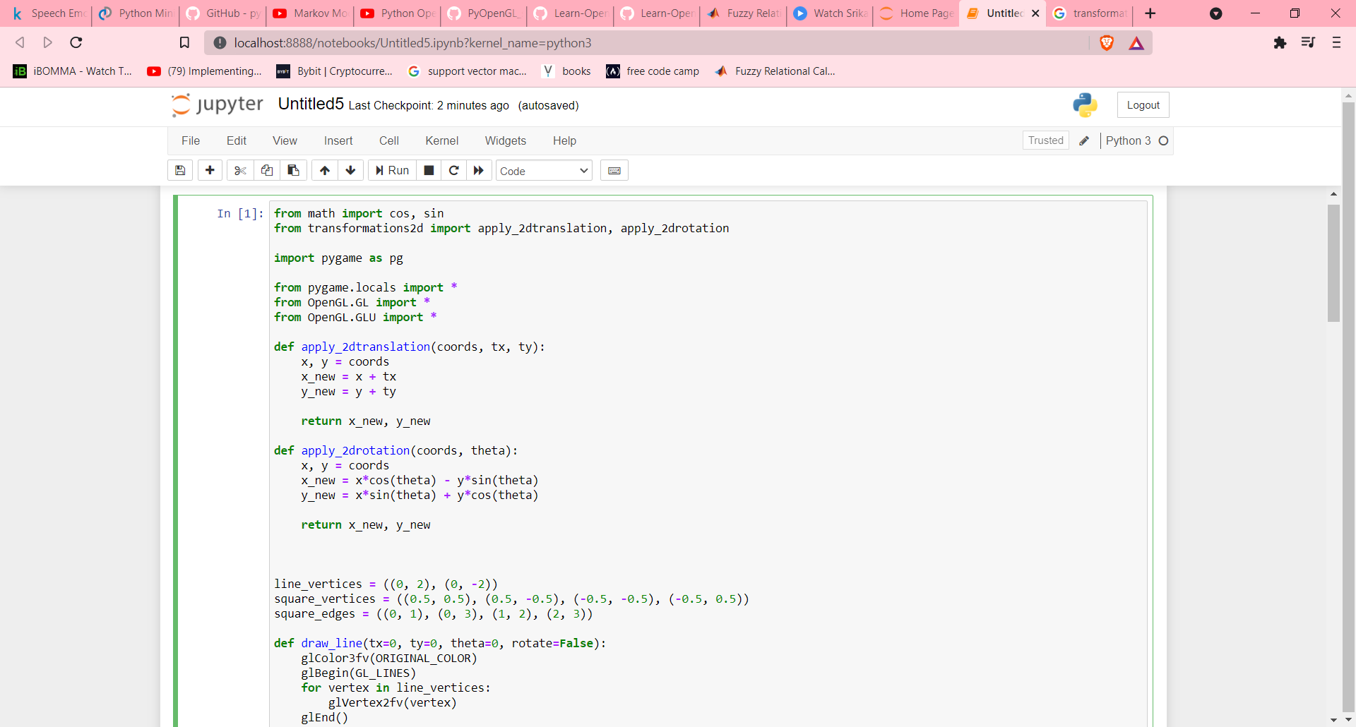

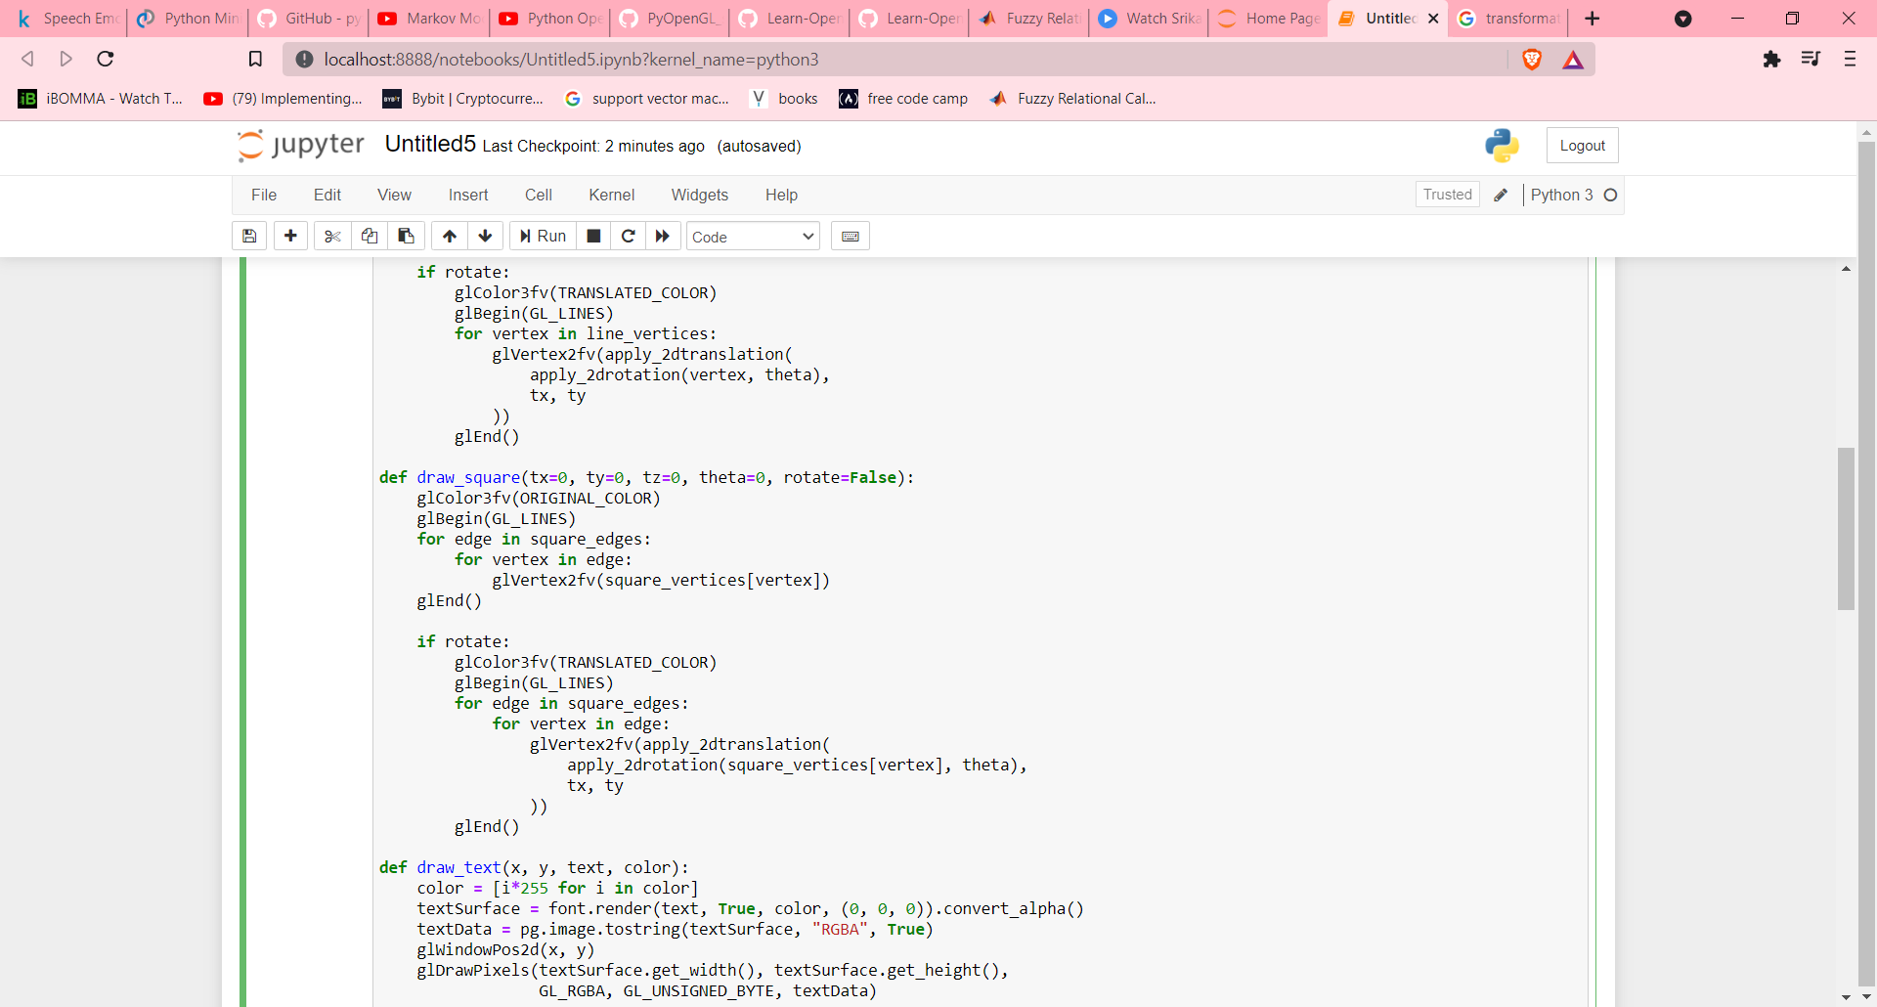

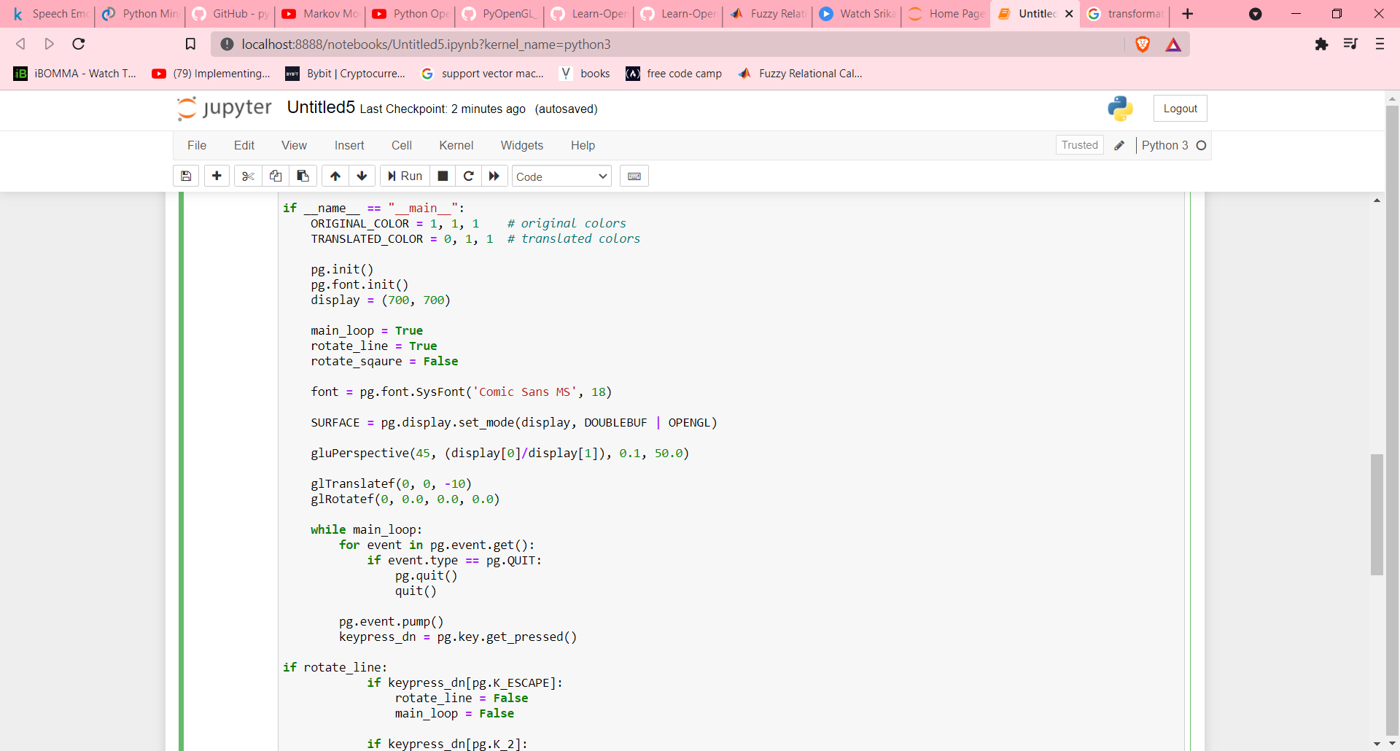

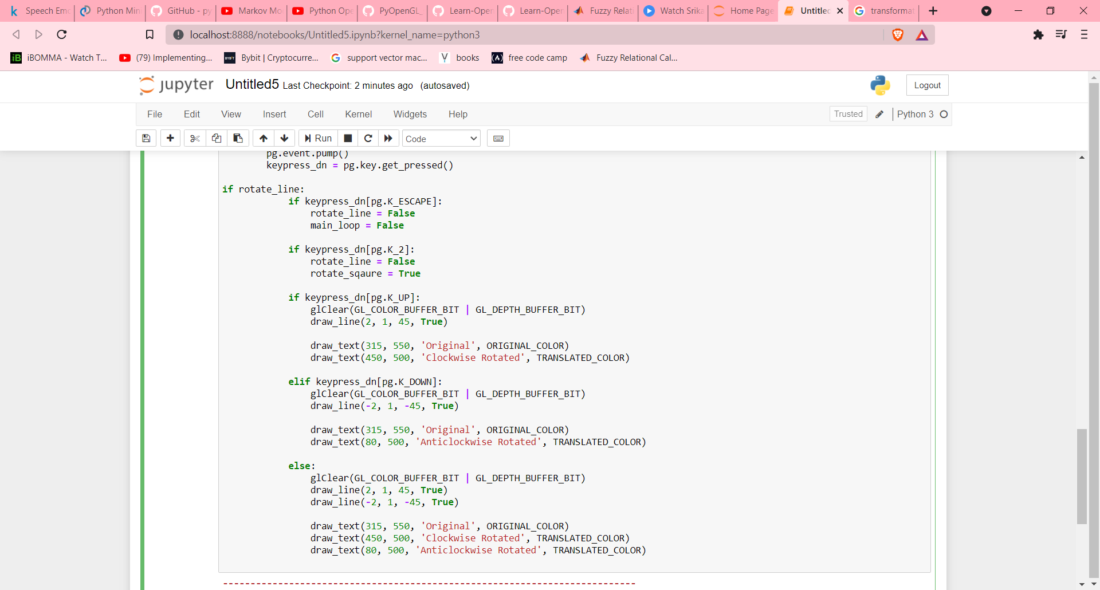

Output:

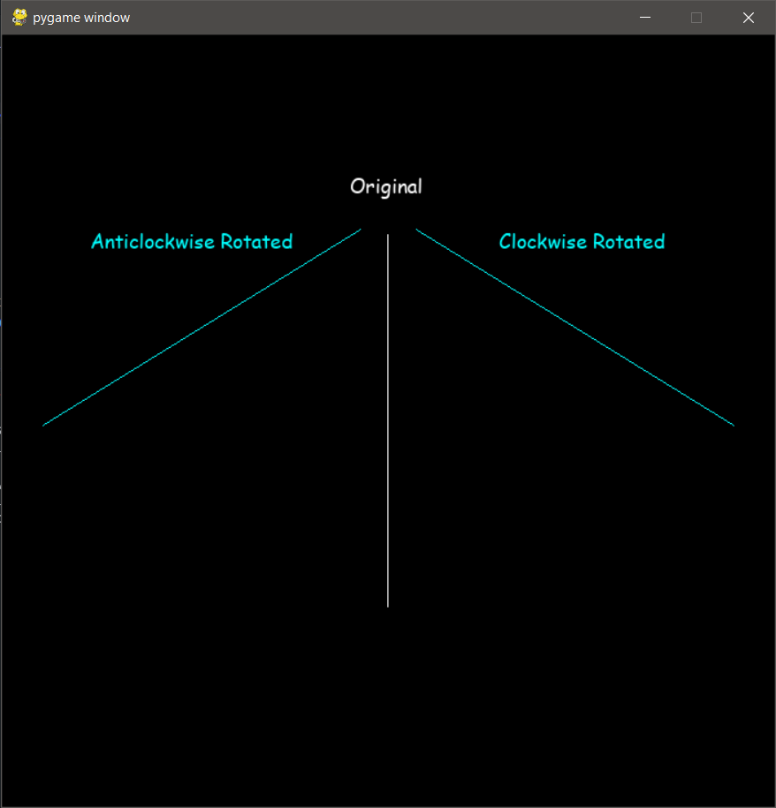

**Experiment – 5 Date: 17 Aug 2021**

**Aim:** To Perform 2D translation, rotation, scaling with python and OpenGL.

**Programing Language:** python

**Theory:**

**Translation:**

Translation is a process of changing the position of an object in a straight-line path from one coordinate location to another. We can translate a two-dimensional point by adding translation distances, tx and ty.

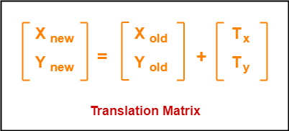

**Rotation:**

A rotation is a transformation in which the object is rotated about a fixed point or a line. The direction of rotation can be clockwise or anticlockwise. The fixed point in which the rotation takes place is called the centre of rotation. The amount of rotation made is called the angle of rotation. For any rotation, we need to specify the centre, the angle, and the direction of rotation.



**Scaling:**

In the scaling process, you either expand or compress the dimensions of the object. Scaling can be achieved by multiplying the original coordinates of the object with the scaling factor to get the desired result.

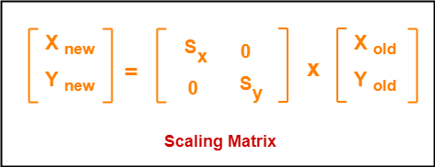

**Code:**

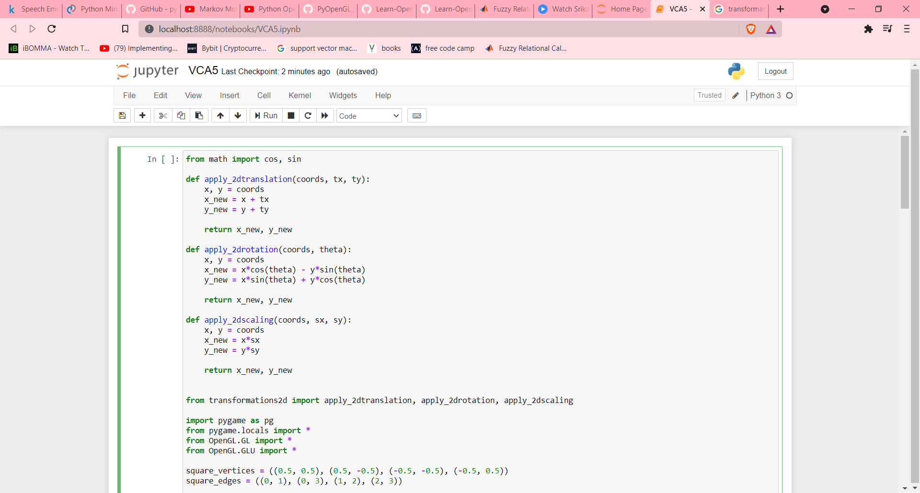

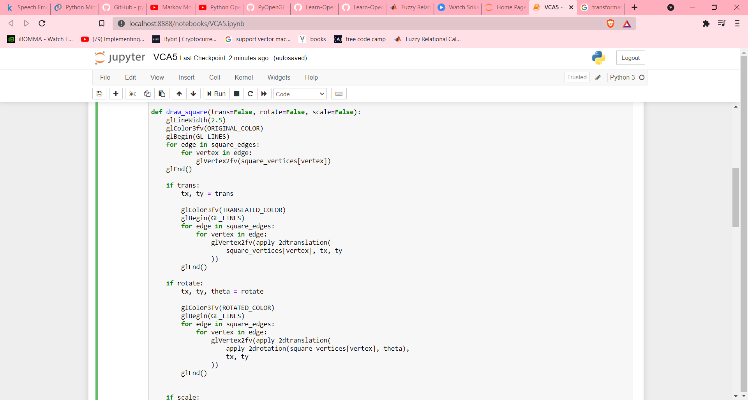



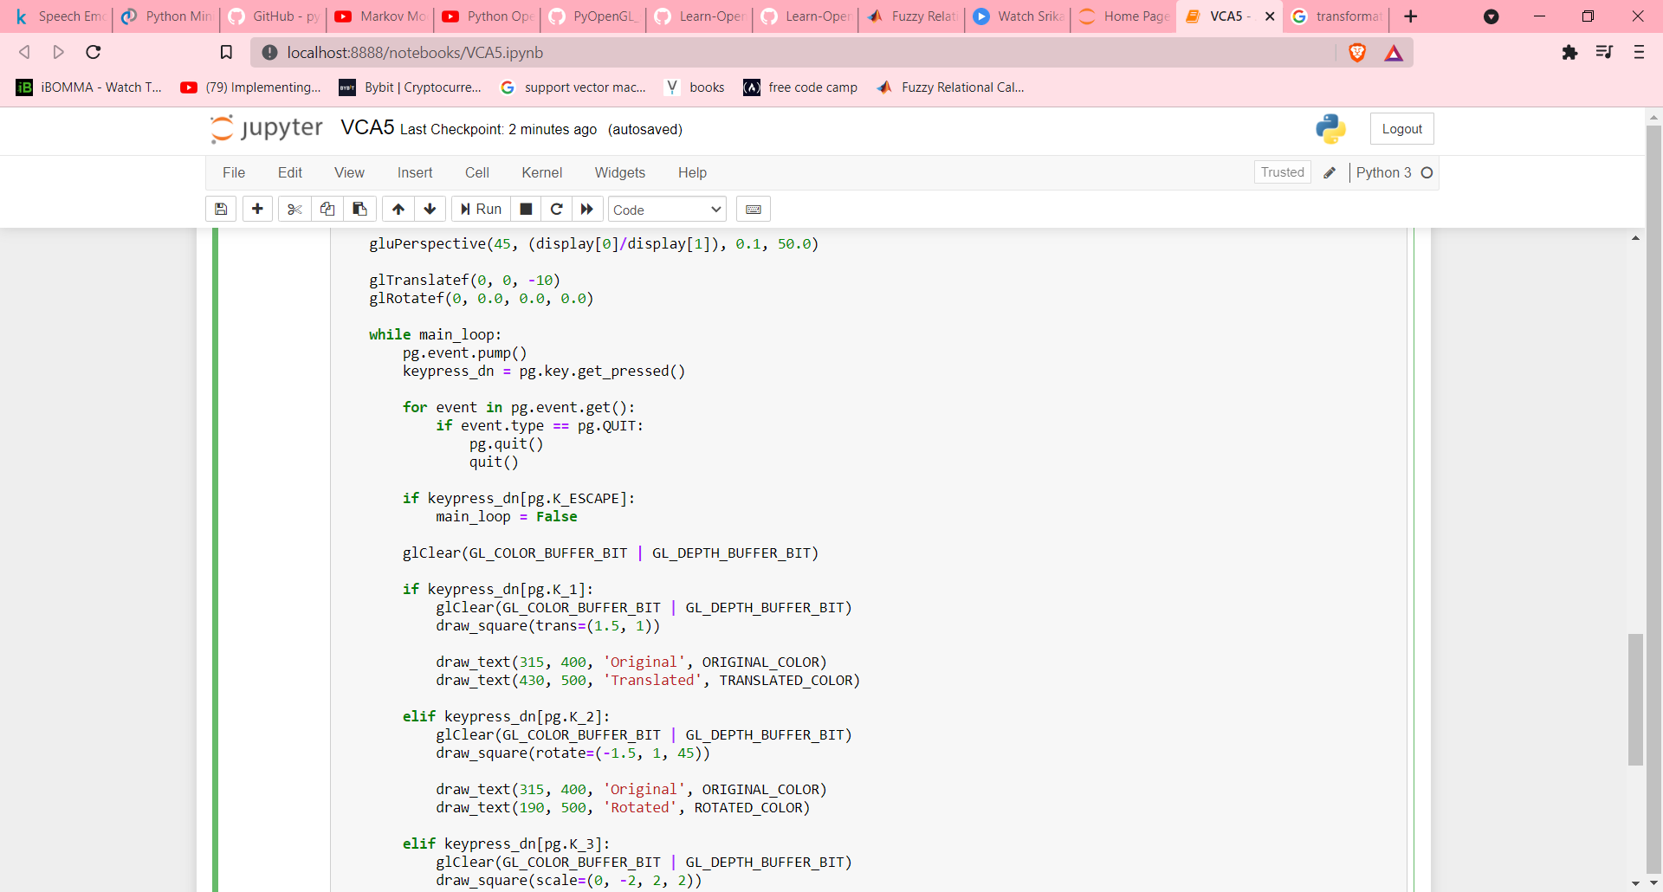

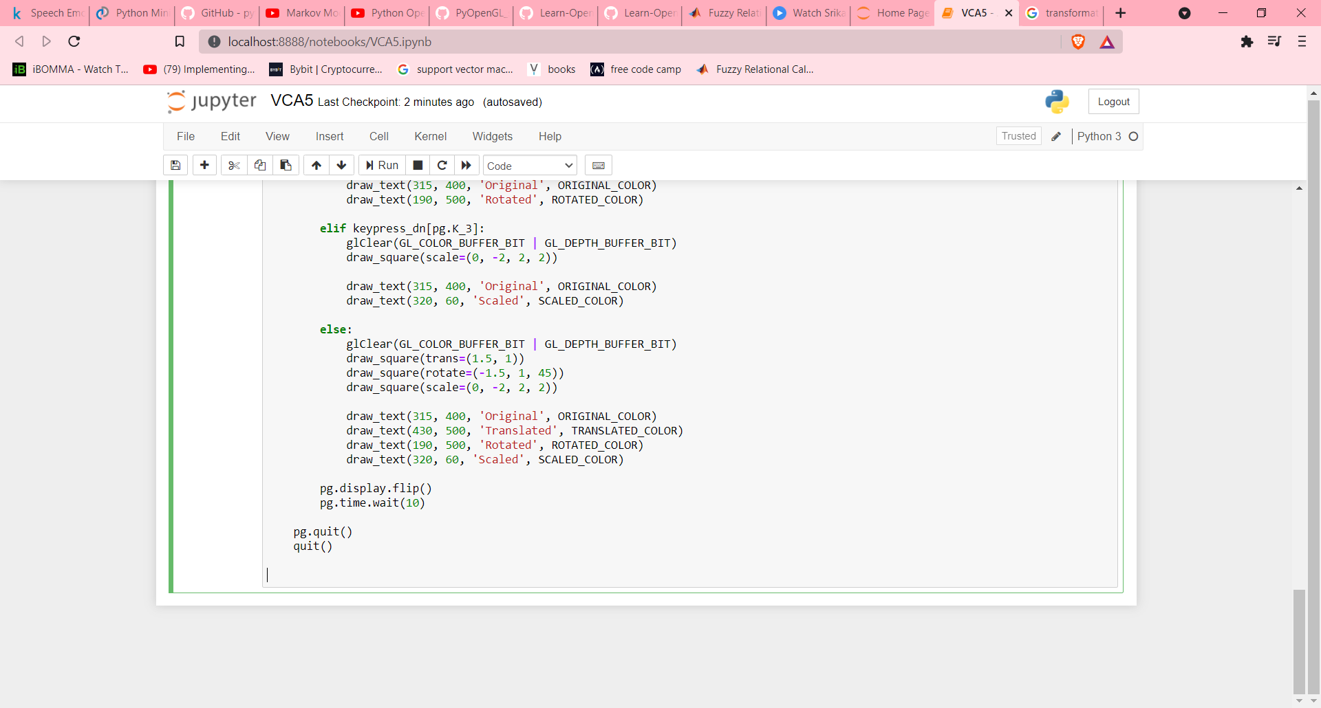

**Output:**

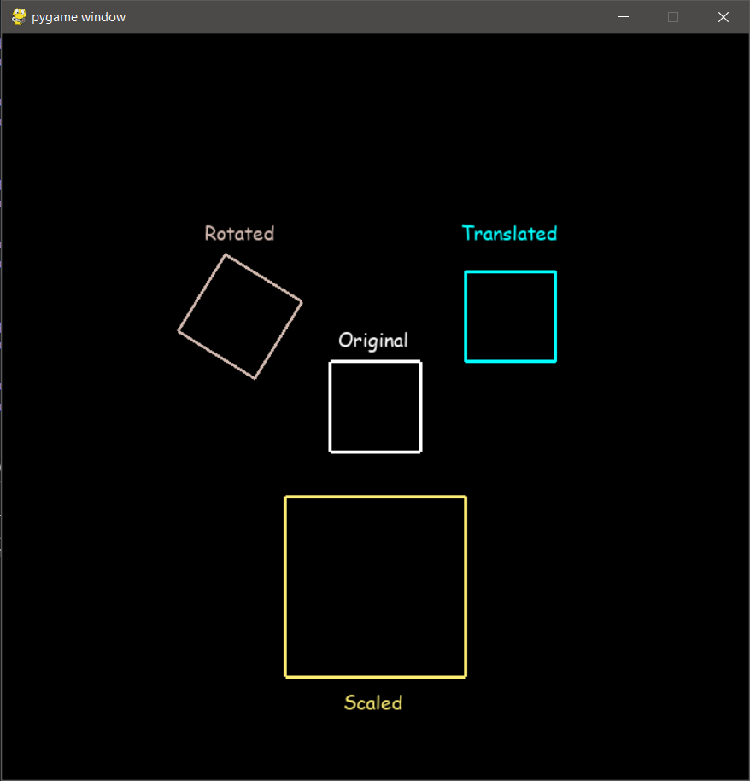

**Experiment – 6 Date: 24 Aug 2021**

**Aim:** To Perform 3D translation, rotation, scaling with python and OpenGL.

**Programing Language:** python

**Theory:**

**Translation:**

Translation is the process of changing the relative location of a 3-D object with respect to the original position by changing its coordinates.

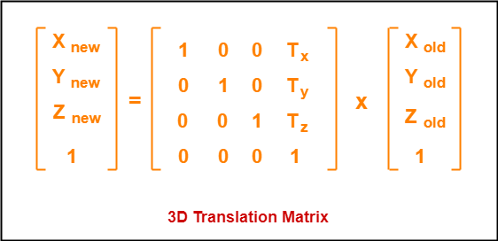

**Rotation:**

Arbitrary rotation is of 3 kinds, in this we can rotate an object just parallel(or along) a specific axis so that the coordinate about which the object rotates, remains unchanged and the rest two of the coordinates get changes.

X-axis:

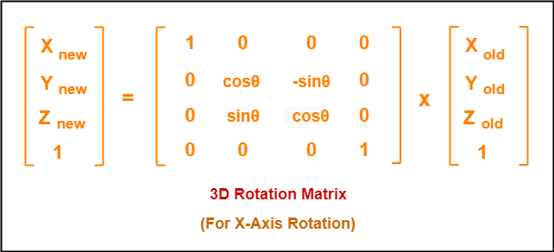

Y-axis

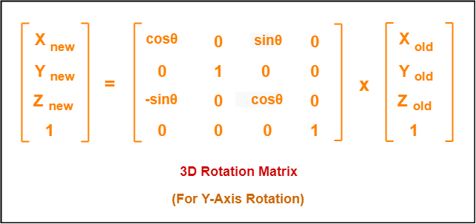

Z-axis

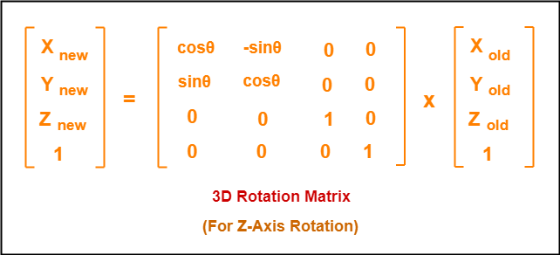

**Scaling:**

Scaling is performed to resize any 3D-object so that the dimension of the object can be scaled or altered in any of the x, y, z direction through Sx, Sy, Sz scaling factors.

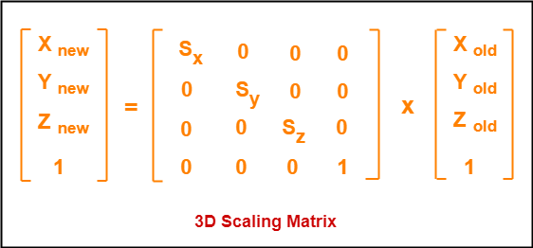

**Code:**

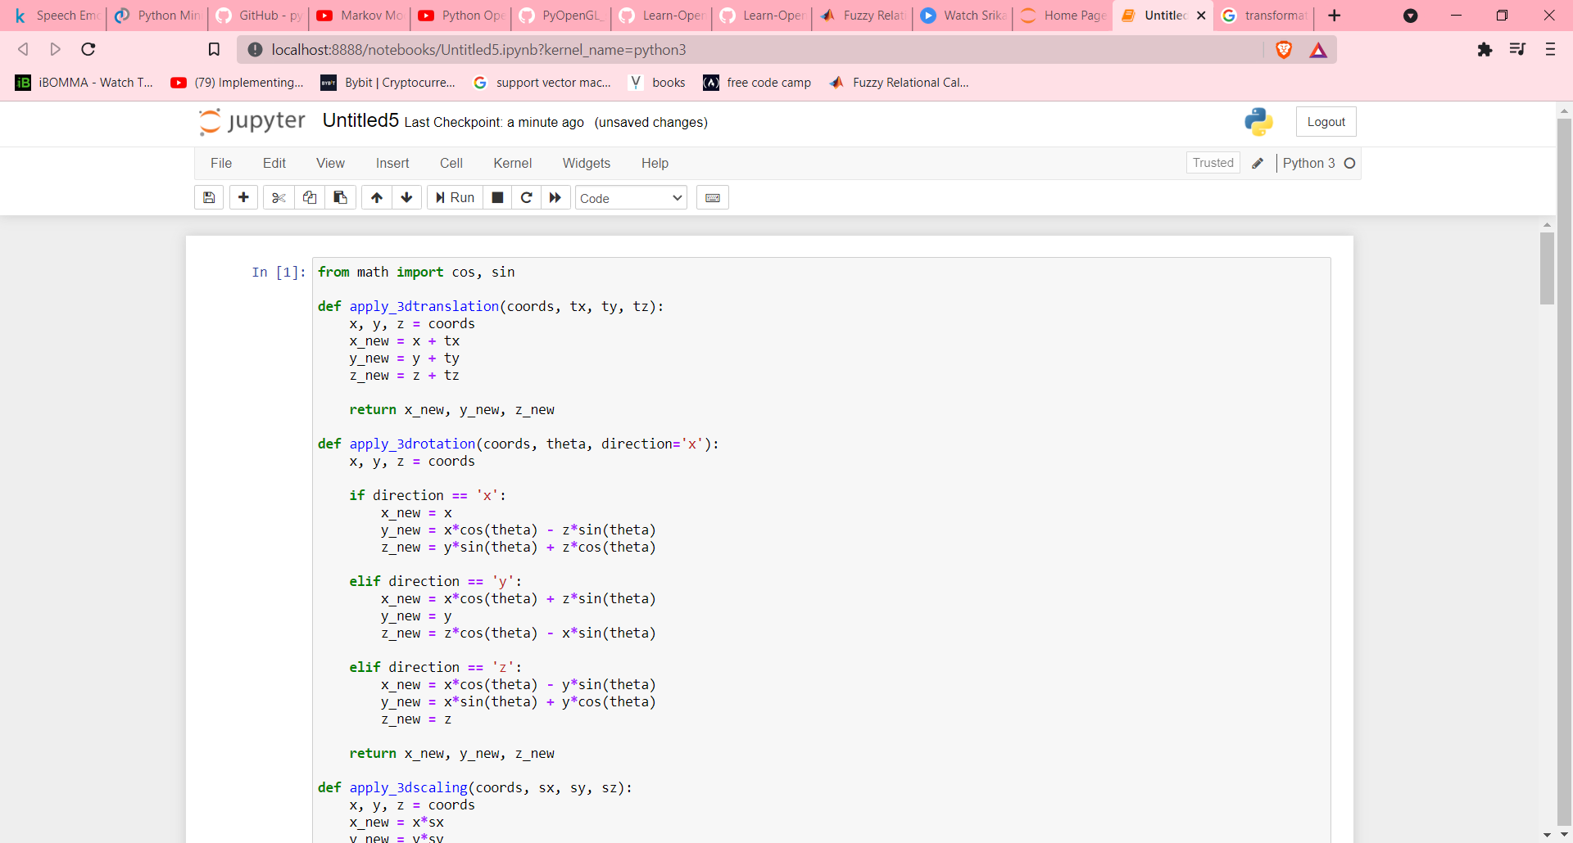

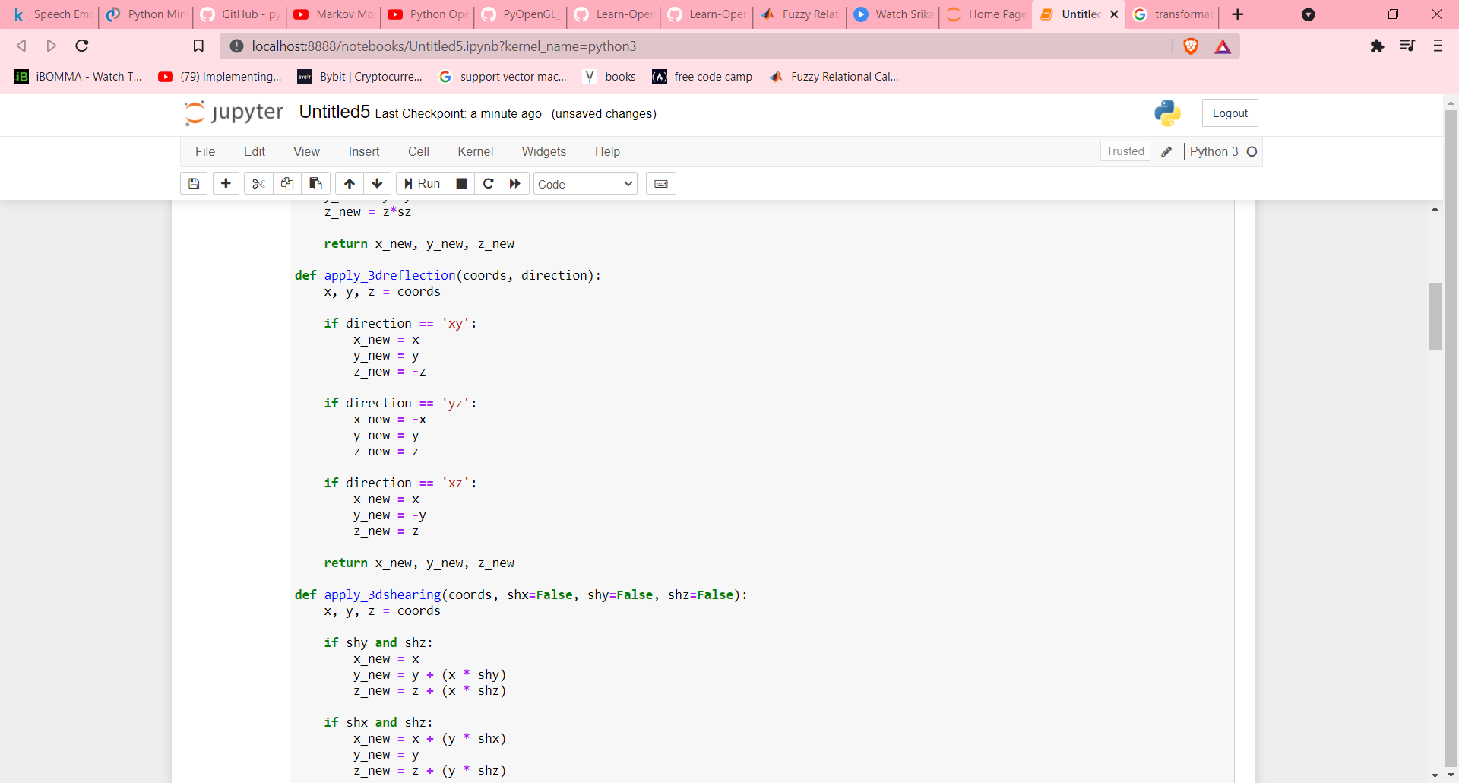

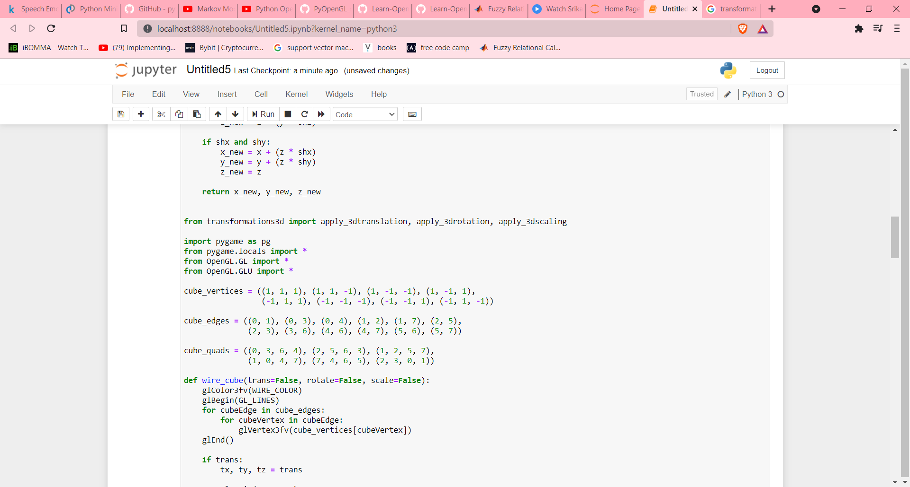

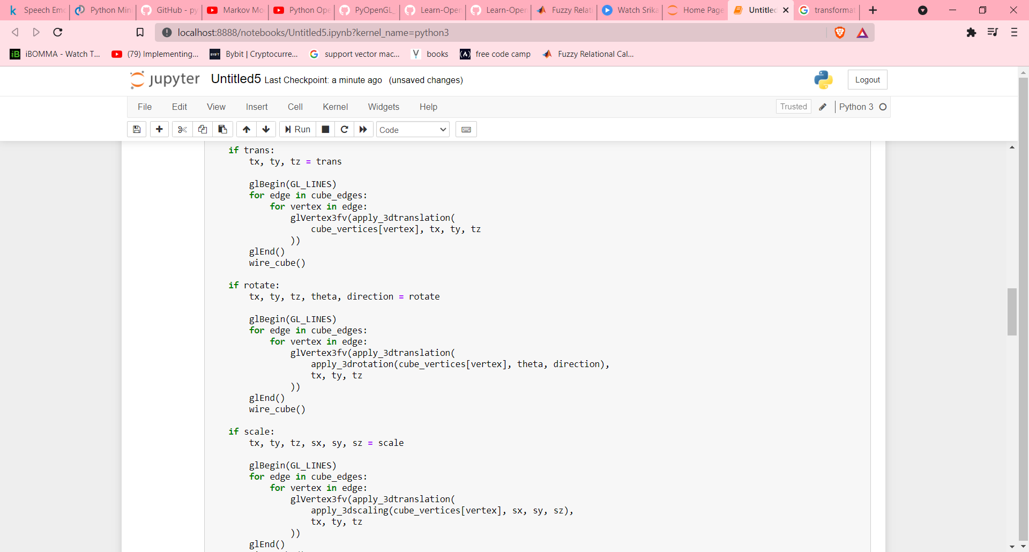

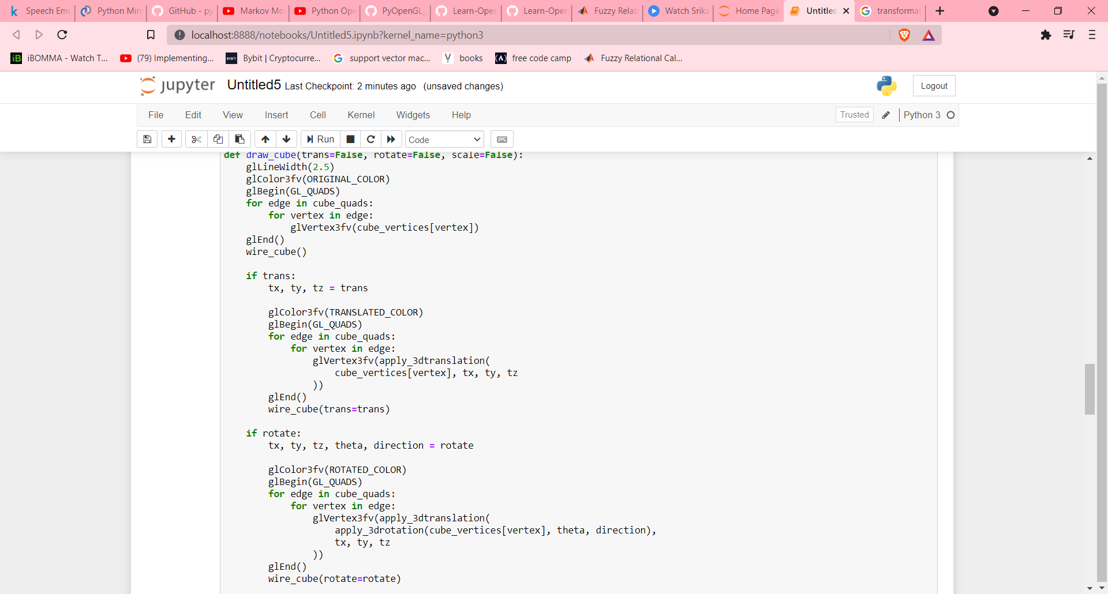

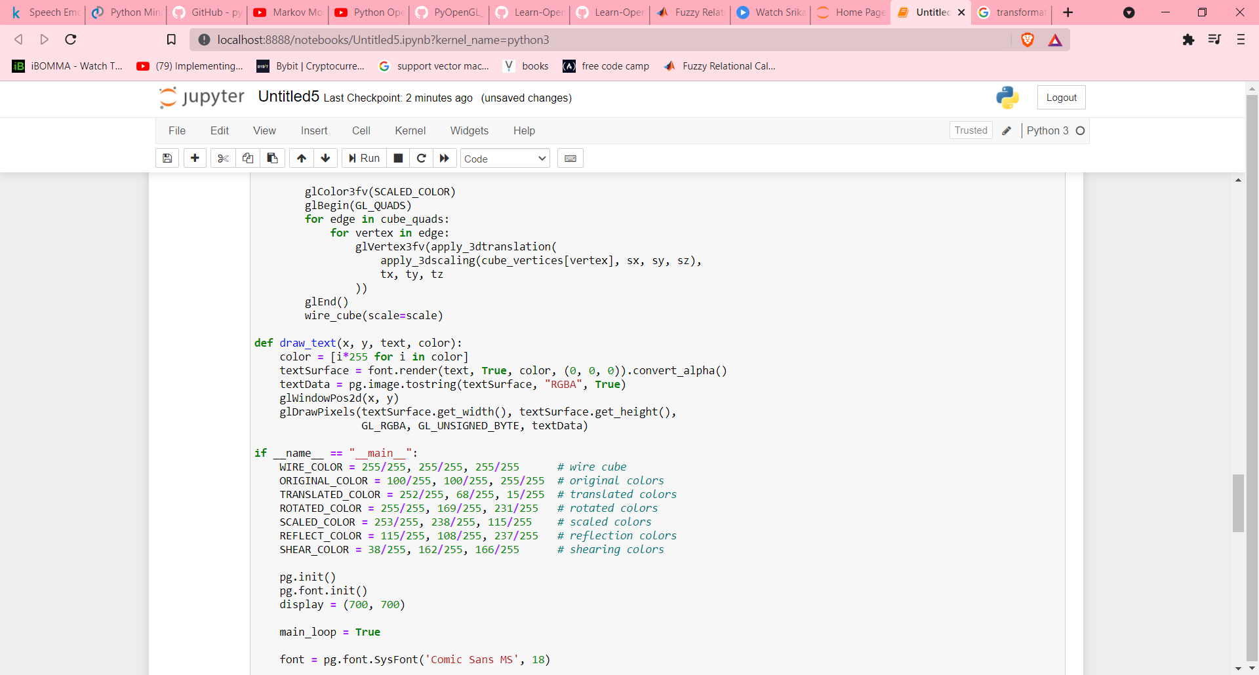

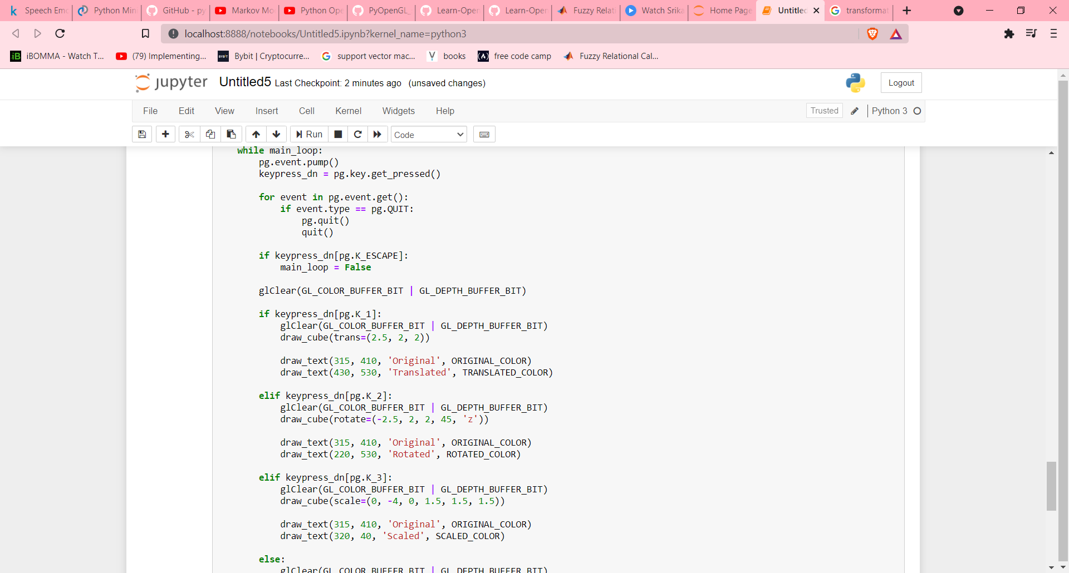

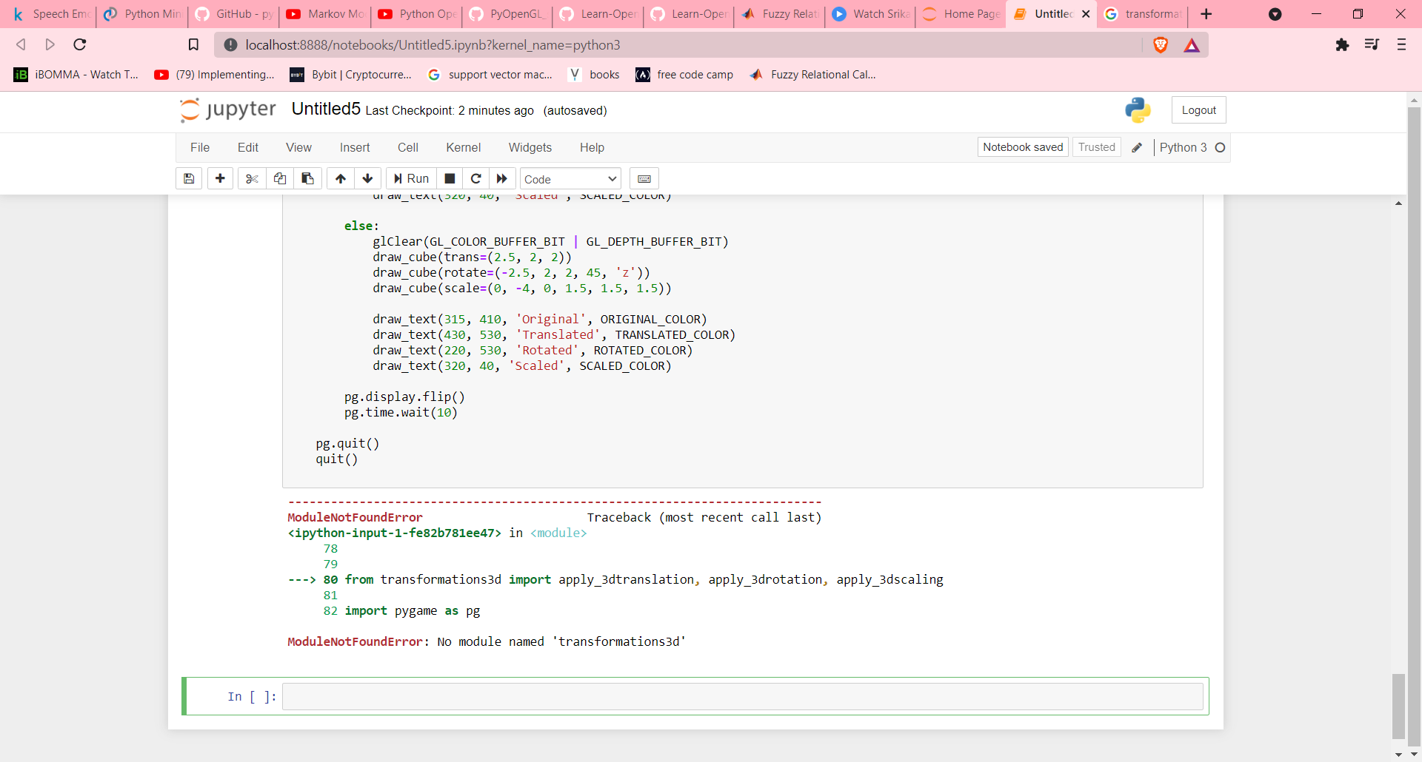

Output:

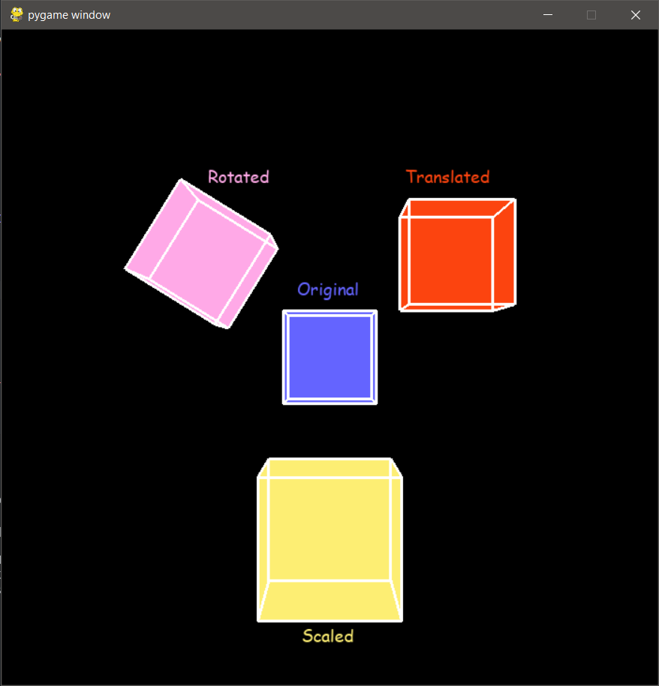

**Experiment – 7 Date: 31 Aug 2021**

**Aim:** To Implementing line drawing algorithms.

**Programing Language:** python

**Theory:**

A line connects two points. It is a basic element in graphics. To draw a line, you need two points between which you can draw a line. In the following three algorithms, we refer the one point of line as X0, Y0 and the second point of line as XN, YN

There are three types of line drawing algorithms in computer graphics.

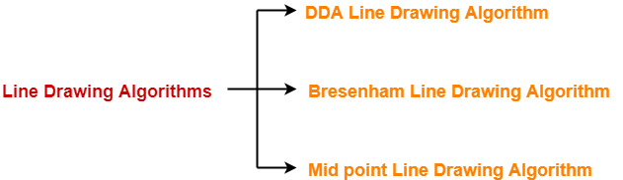

### DDA Algorithm:

1. Get two input points (X0, Y0) and (XN, YN)
2. Get the absolute difference for the x and y coordinates and the parameter M. $∆X=X_{N}-X_{0}$ 
    and $∆Y=Y_{N}-Y_{0}$ $M={∆Y}/{∆X}$
3. Based on M, calculate Xp+1 and Yp+1

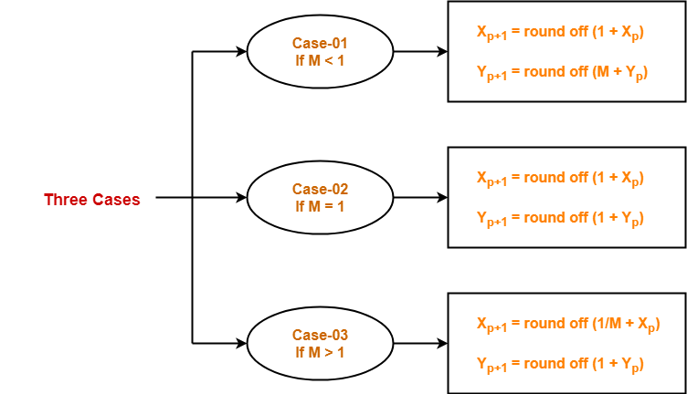

### Bresenham’s Line Generation:

1. Get two input points (X0, Y0) and (XN, YN)
2. Get the absolute difference for the x and y coordinates and the parameter M. $∆X=X_{N}-X_{0}$ 
    and $∆Y=Y_{N}-Y_{0}$ $P_{k}=2∆Y-∆X$
3. Based on Pk, calculate Xp+1 and Yp+1

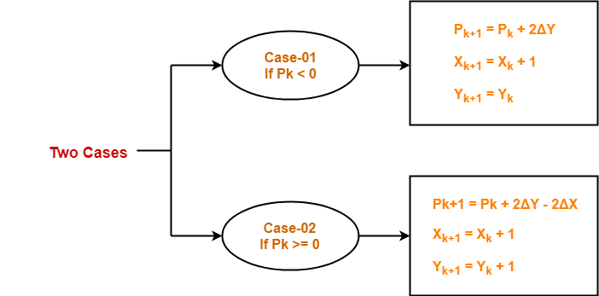

### Mid-Point Algorithm

1. Get two input points (X0, Y0) and (XN, YN)
2. Get the absolute difference for the x and y coordinates and the parameter M. $∆X=X_{N}-X_{0}$ 
    and $∆Y=Y_{N}-Y_{0}$ $D_{initial}=2∆Y-∆X$ 
    and $∆D=2(∆Y-∆X)$
3. Based on Dinitial, calculate Xp+1 and Yp+1

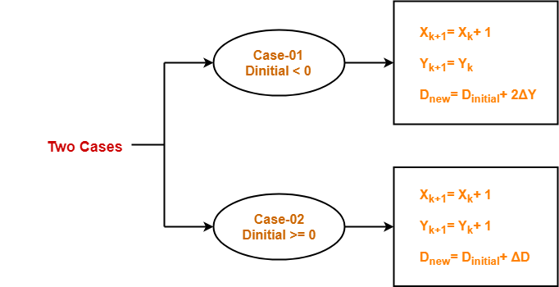

### Code and Output: Bresenham’s Line Generation:

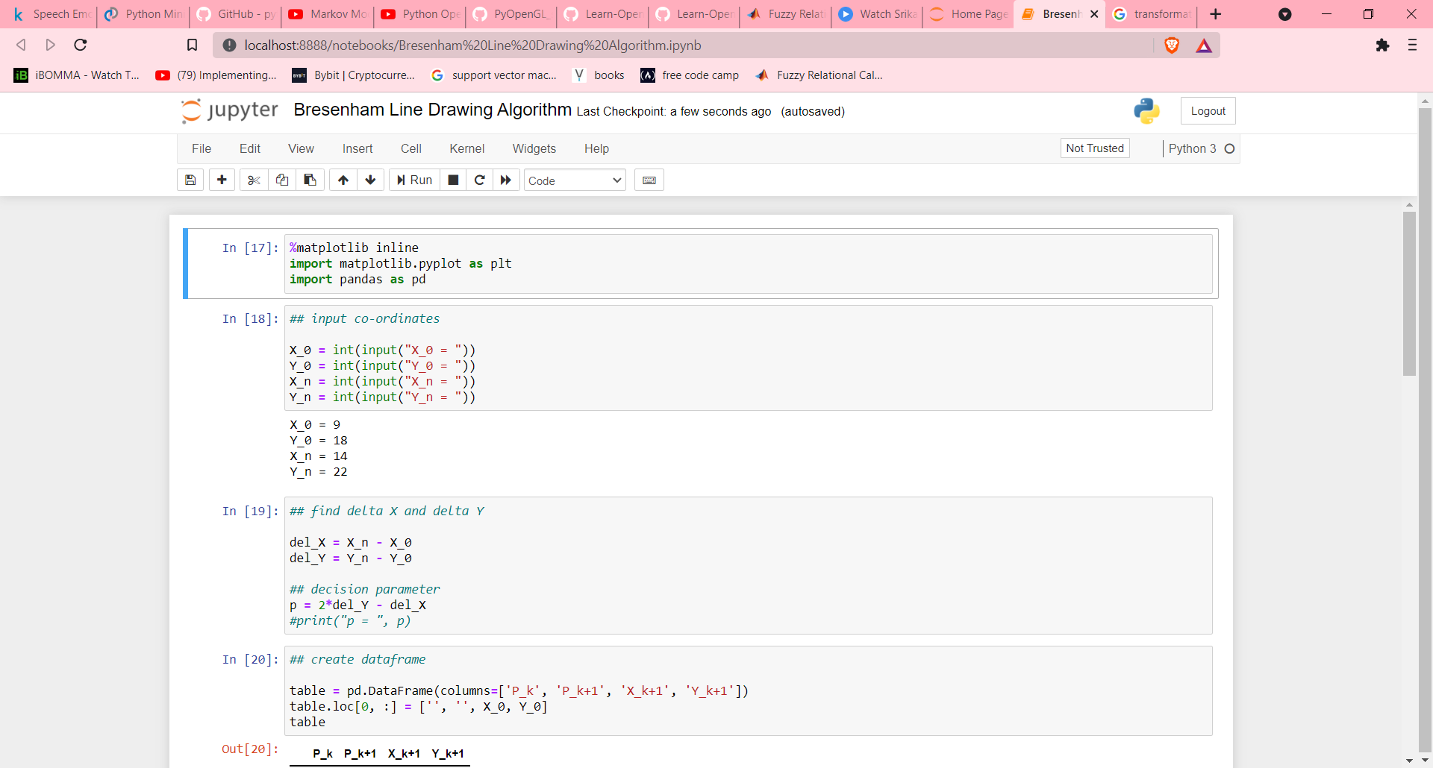

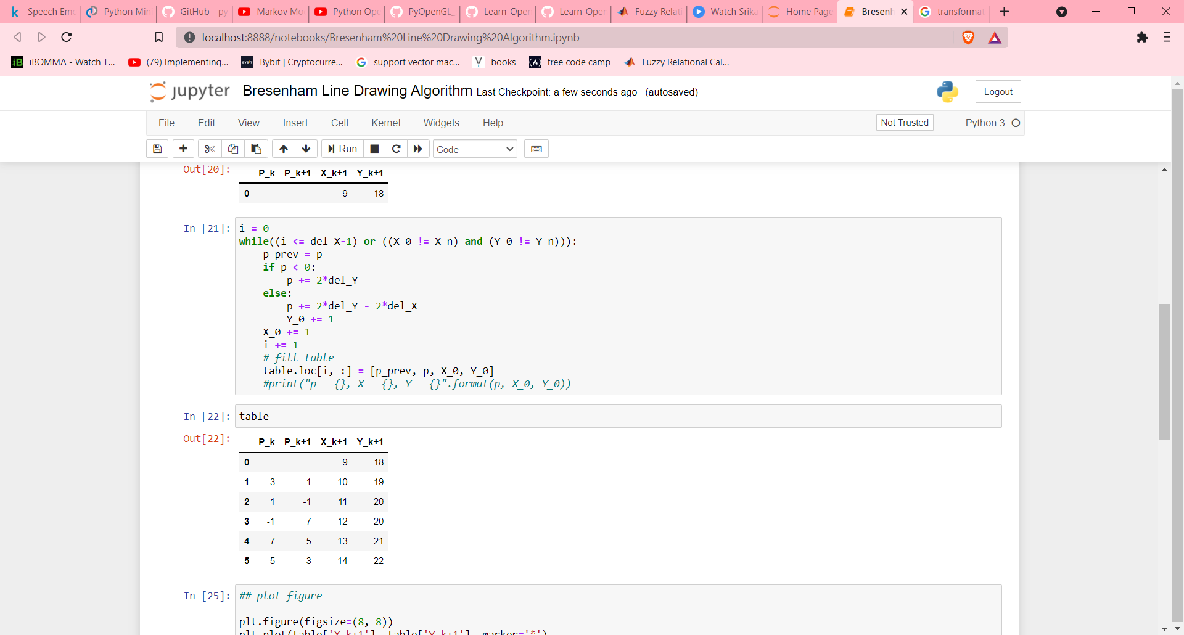

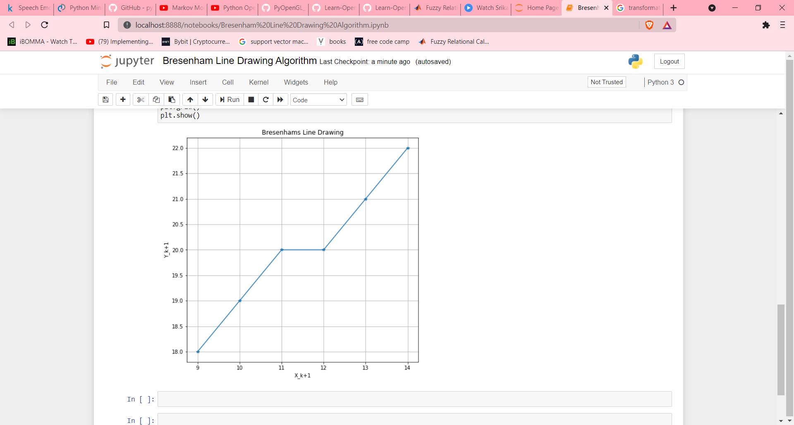

DDA Algorithm:

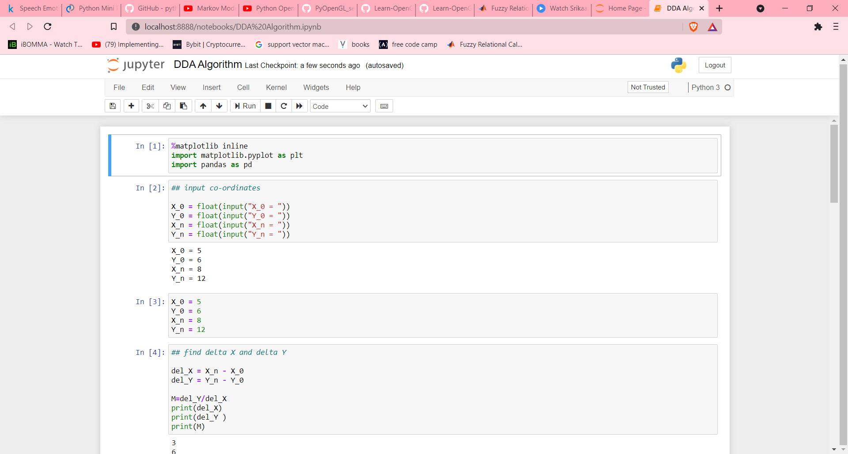

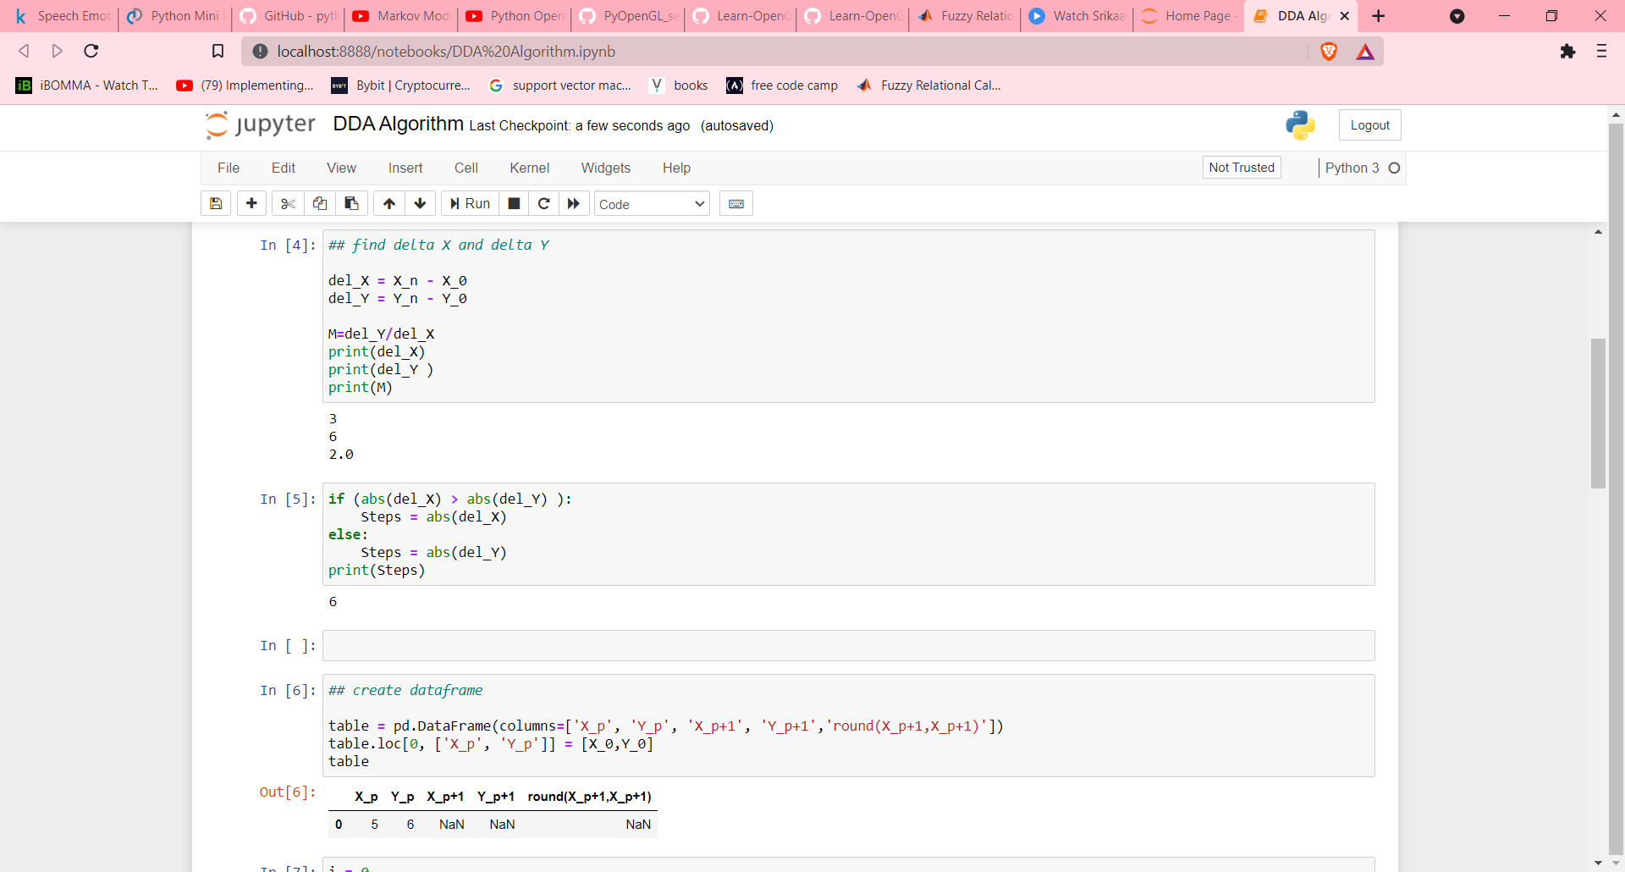

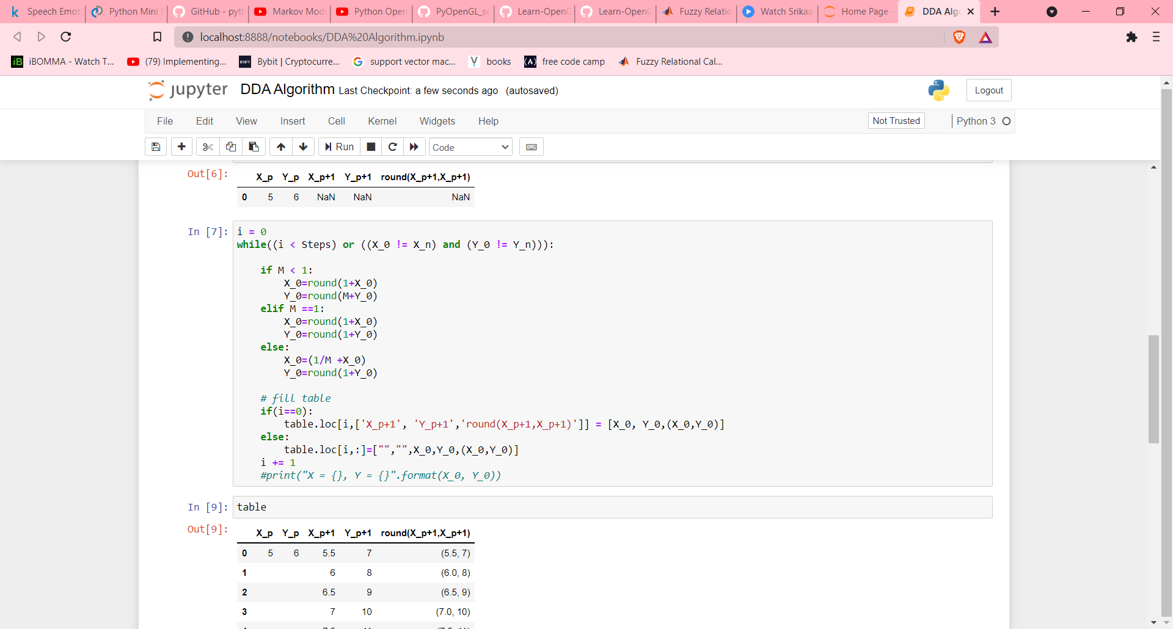

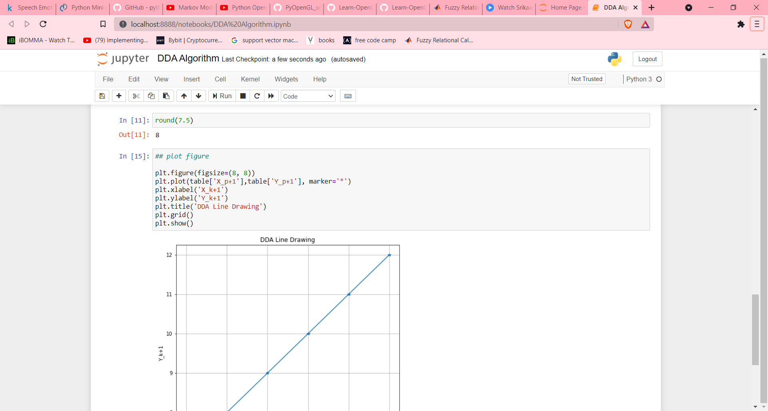

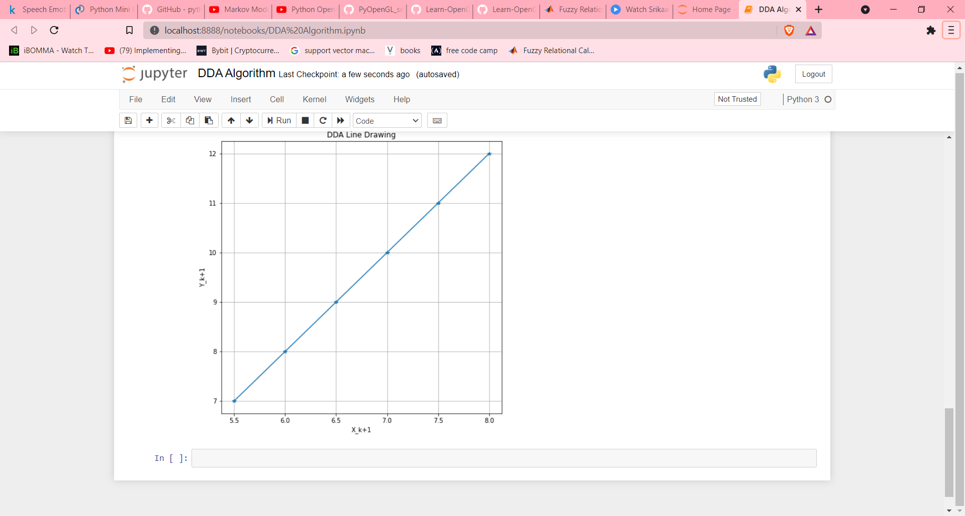

Midpoint Algorithm:

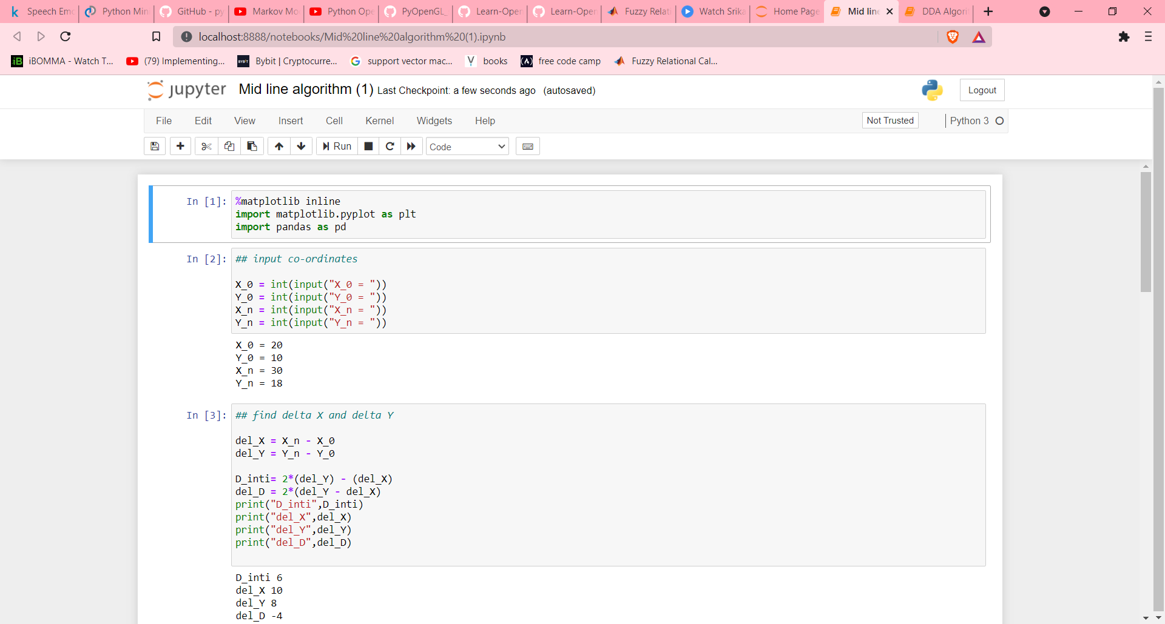

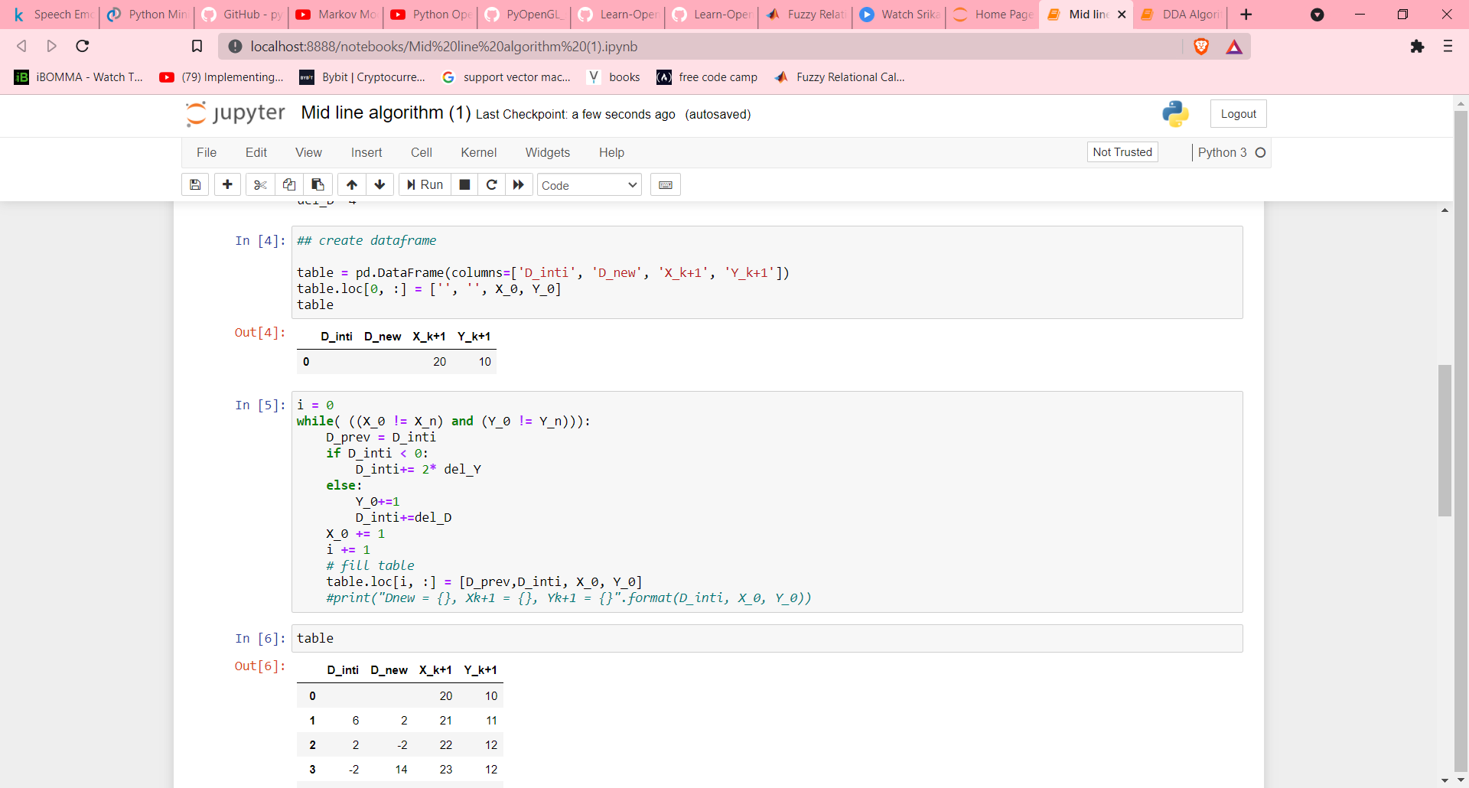

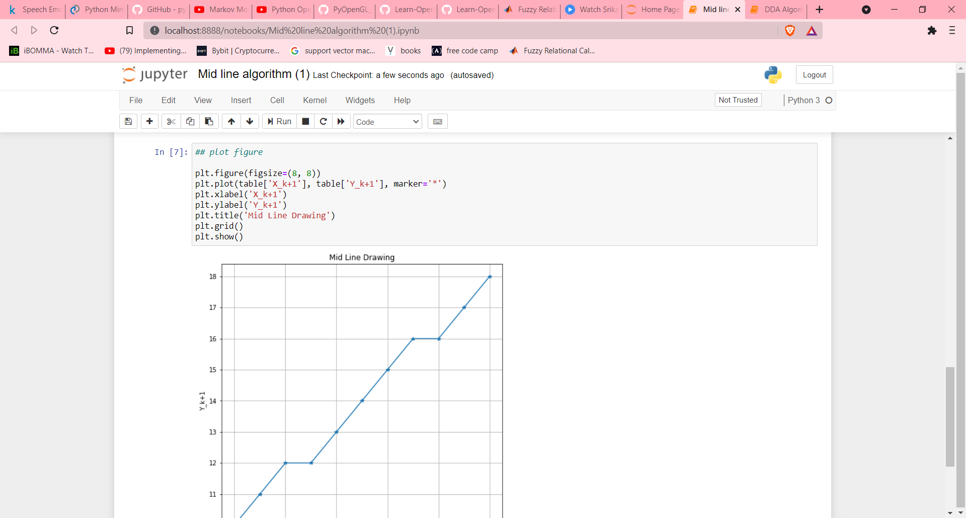

Output:

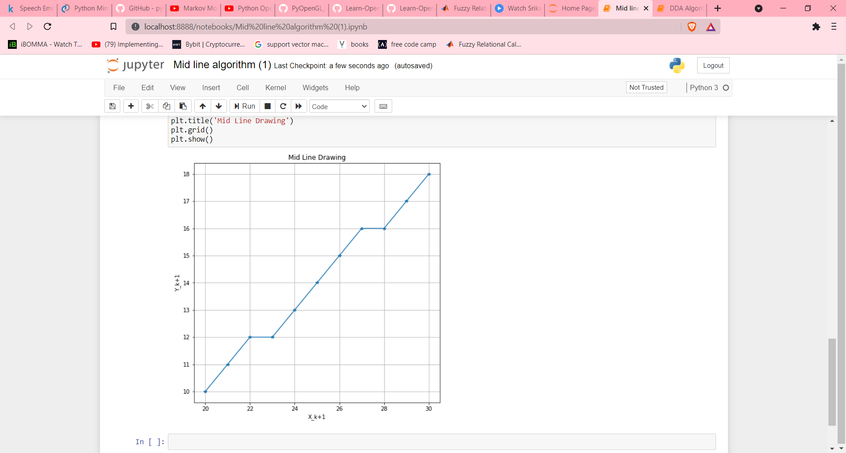

**Experiment – 8 Date: 31 Aug 2021**

**Aim:** To divide screen into four regions, draw circle, rectangle, ellipse, and half ellipse in each region with appropriate message.

**Programing Language:** python

**Theory:**

**Code:**

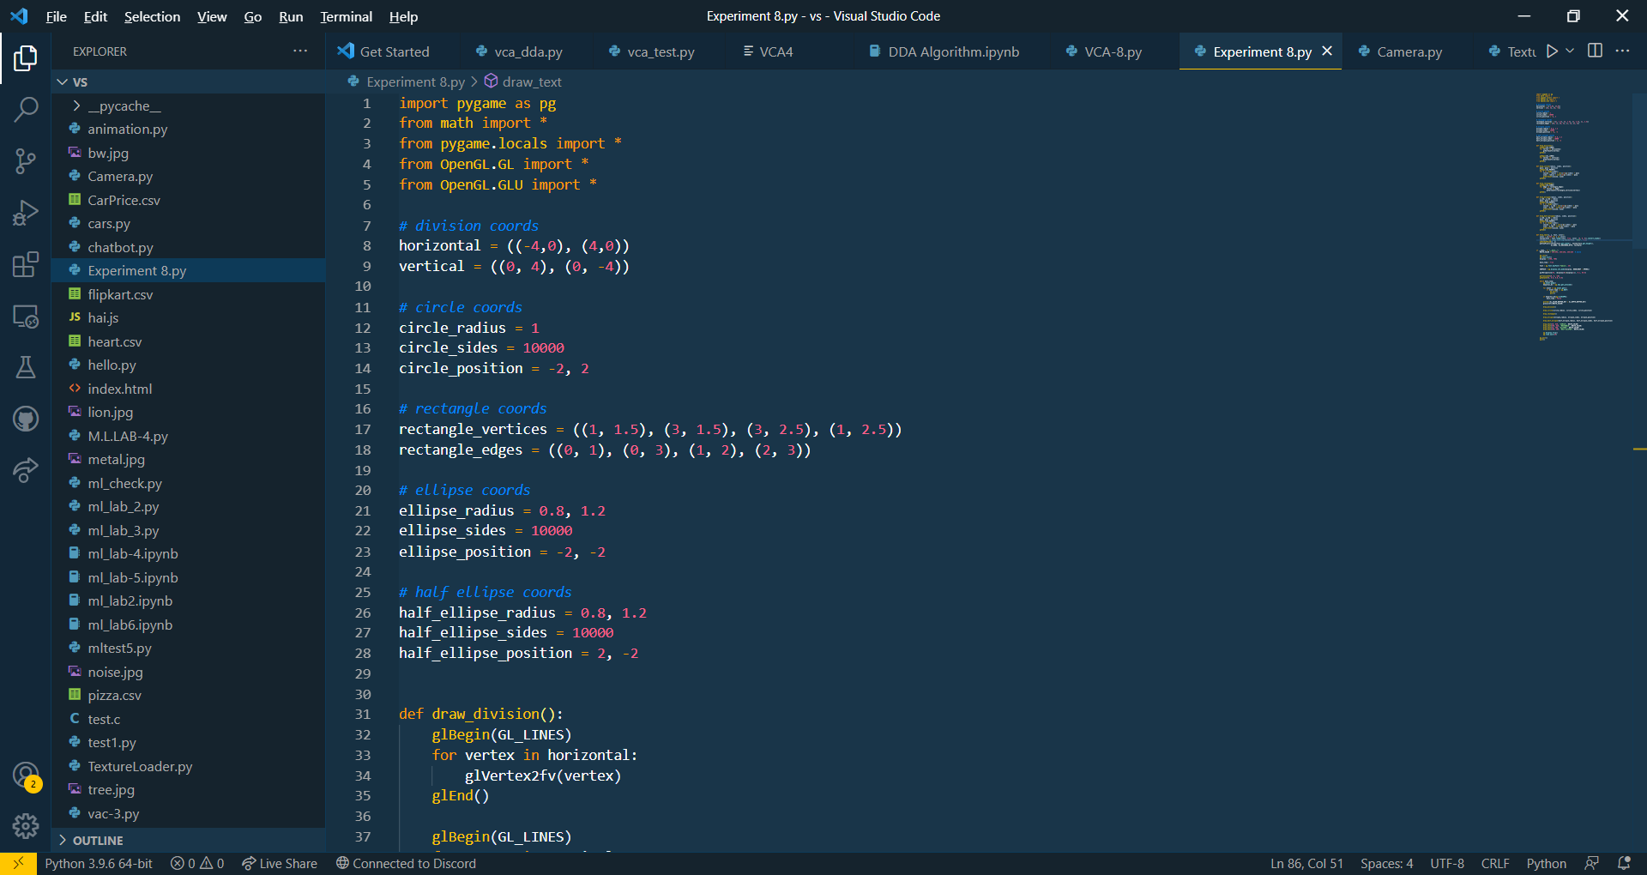

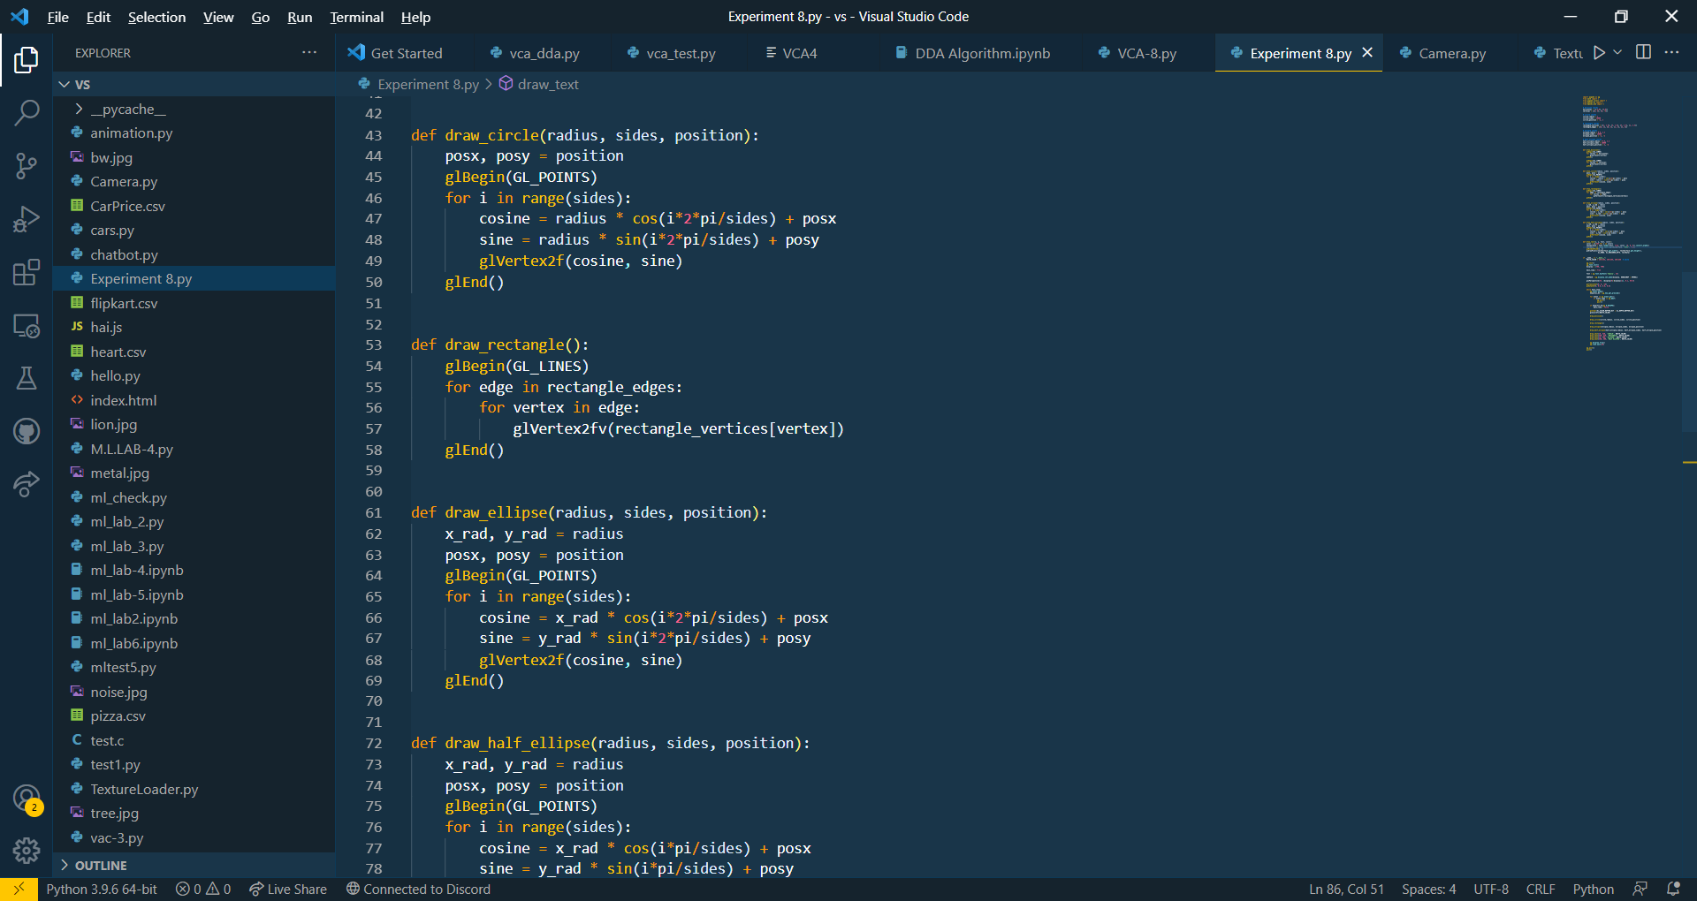

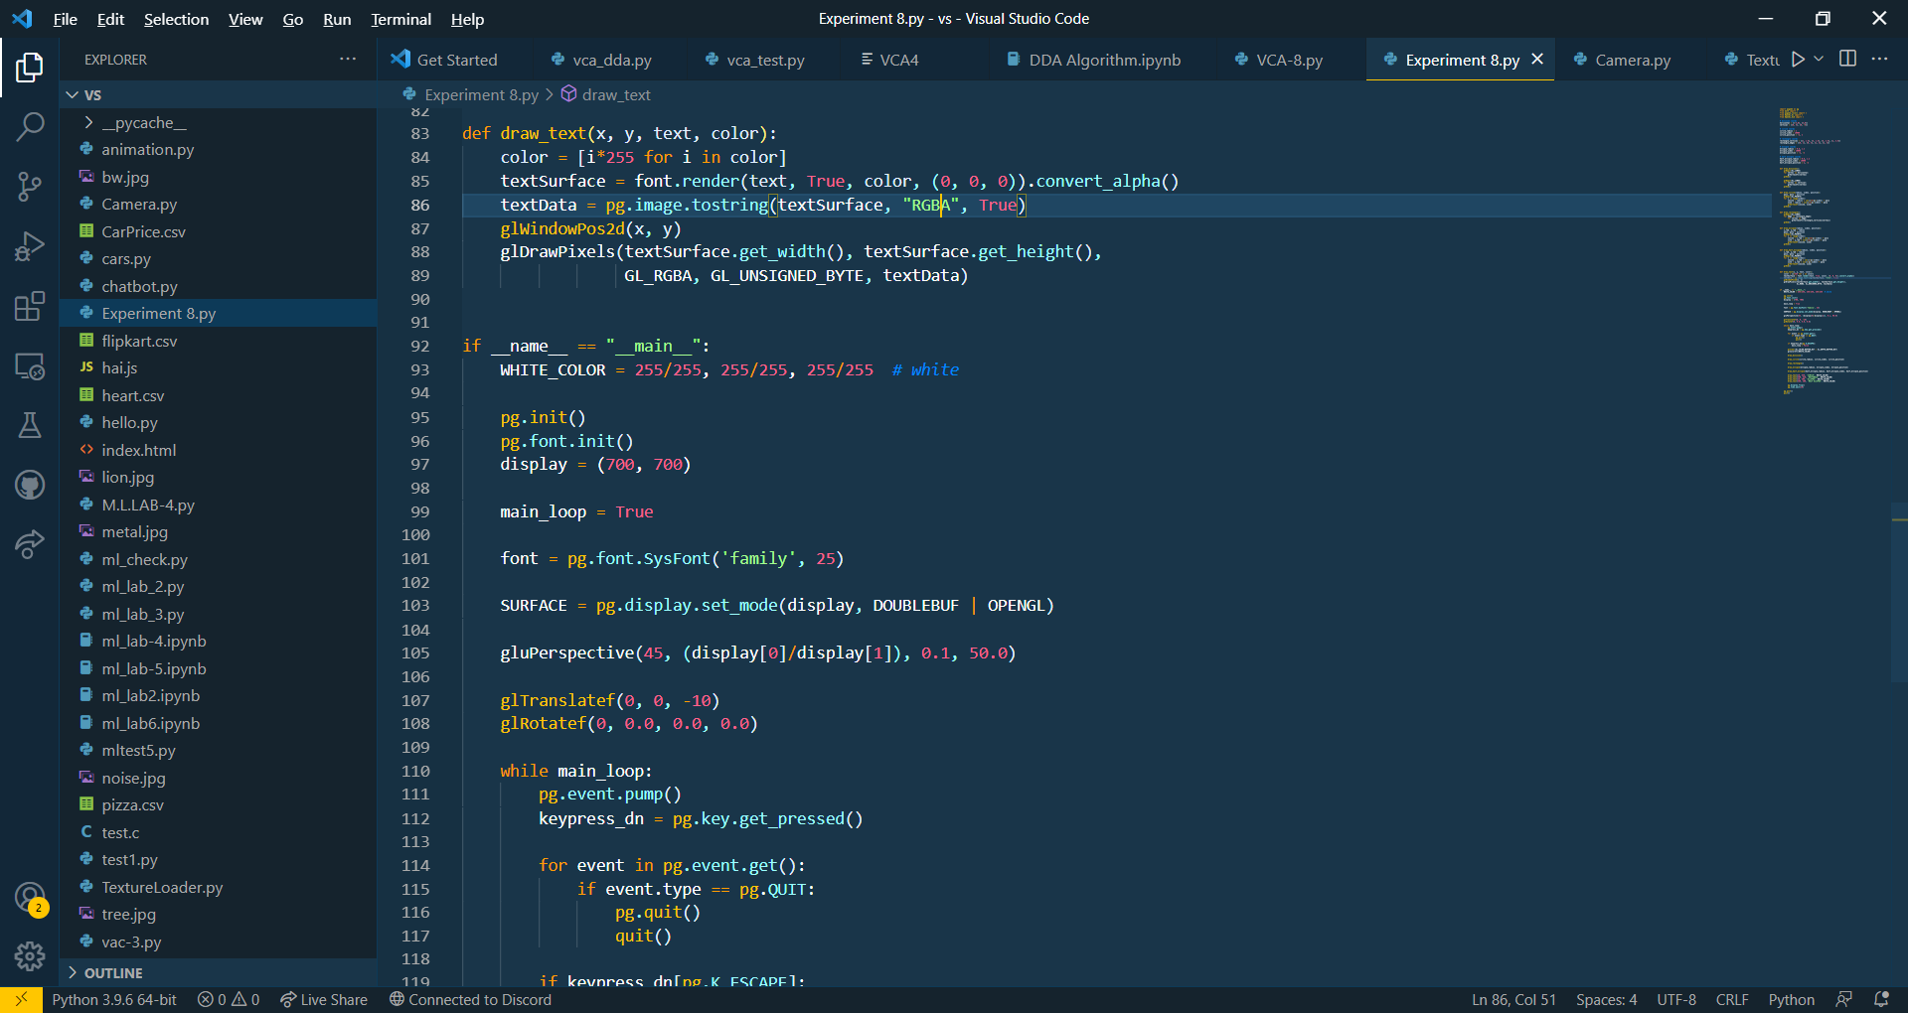

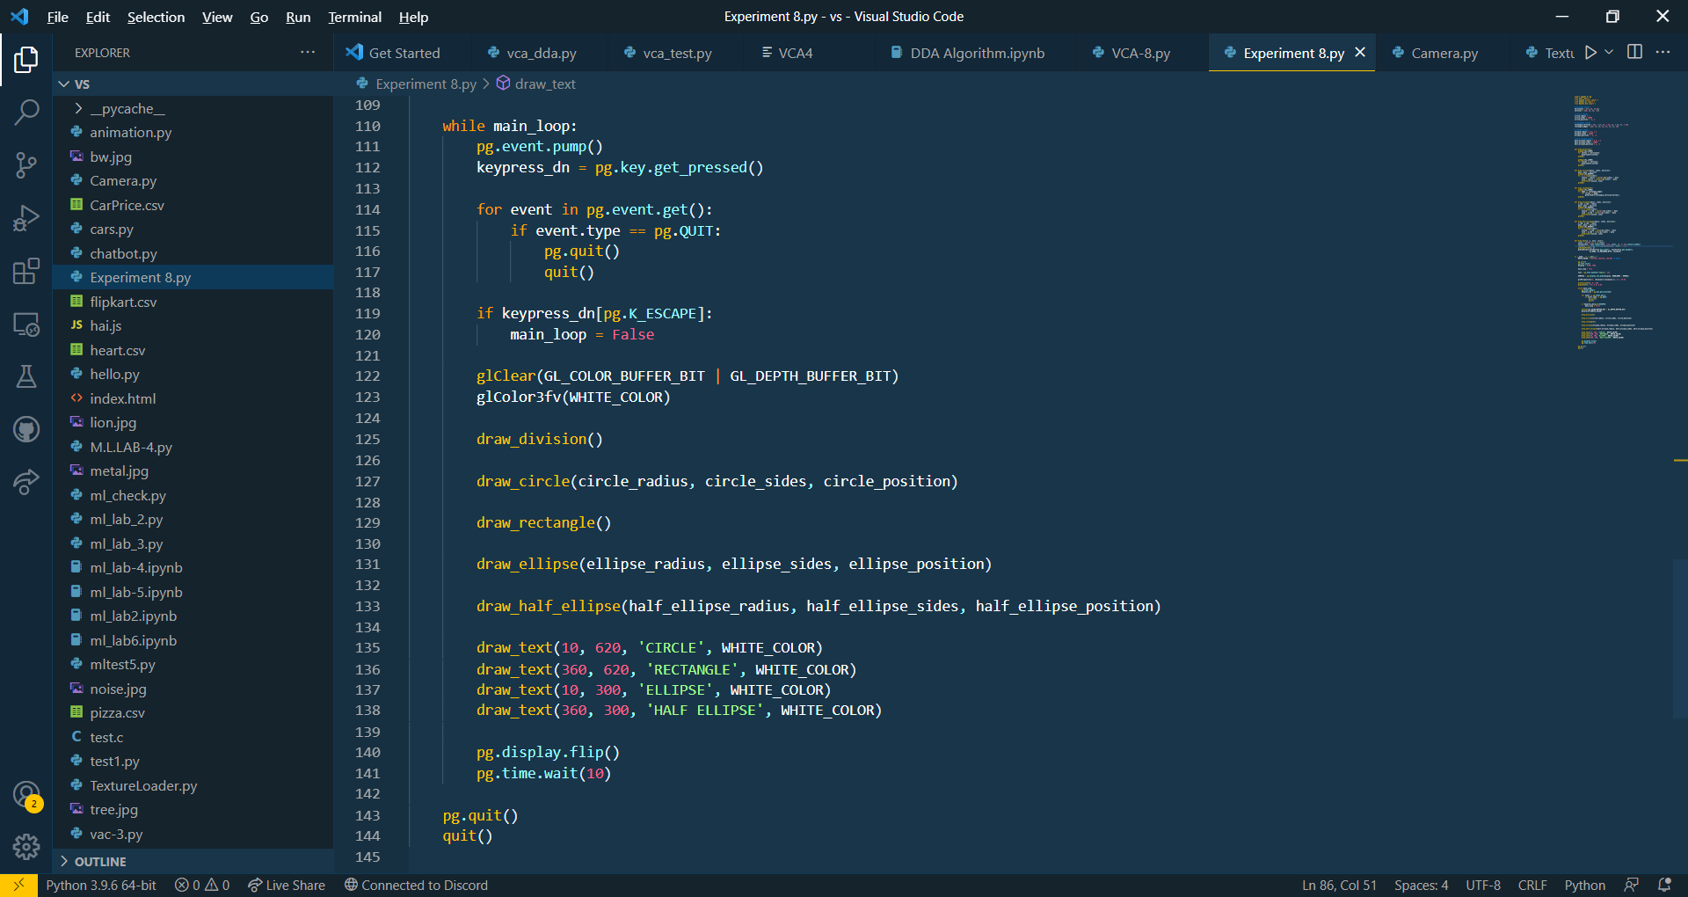

**Output:**

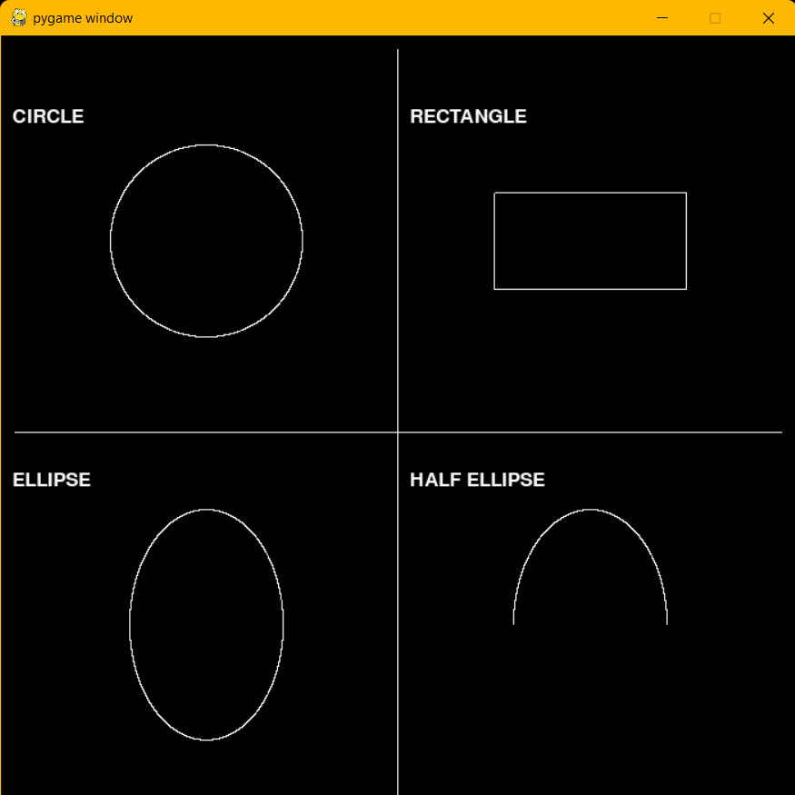

# EXPERIMENT 9

## Aim: **To create a basic animation**

## Tools and technologies used: **Adobe Photoshop.**

## Theory:

Open Photoshop and go to File > Scripts > Load Files into Stack.

Click Browse and locate the photos you want to use. While holding down the Shift key, select all the files and click Open.

Click OK to import the photos into a single layered file.

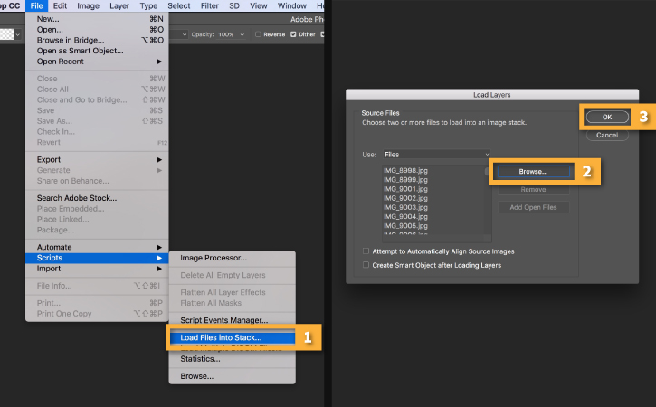

Note that a number of new layers have been created in the Layers panel on the right side of your workspace.

These individual layers will become the frames of the animated GIF.

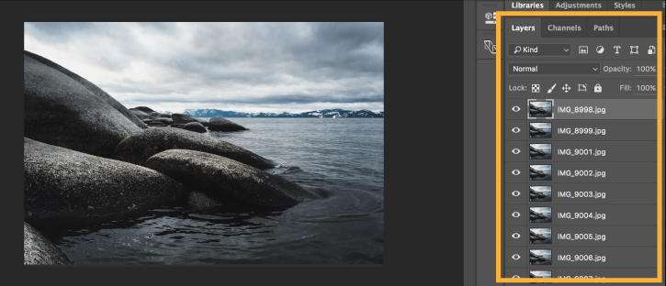

**Open the Timeline**

Go to Window > Timeline to open the Timeline panel.

Click the arrow on the button in the middle of the panel and select Create Frame Animation. Then click the button to create a new frame animation.

## Result:

# EXPERIMENT 10

## Aim: **To create a GIF in adobe Photoshop**

## Tools and technologies used: **Adobe Photoshop.**

## Theory:

Open Photoshop and go to File > Scripts > Load Files into Stack.

Click Browse and locate the photos you want to use. While holding down the Shift key, select all the files and click Open.

Click OK to import the photos into a single layered file.



Note that a number of new layers have been created in the Layers panel on the right side of your workspace.

These individual layers will become the frames of the animated GIF.



**Open the Timeline**

Go to Window > Timeline to open the Timeline panel.

Click the arrow on the button in the middle of the panel and select Create Frame Animation. Then click the button to create a new frame animation.

## Result:



